THE PORT OF
LYME REGIS
(The Cobb)

MARINE OPERATIONS PLAN
(For Compliance with the
Port Marine Safety Code)

August 2019

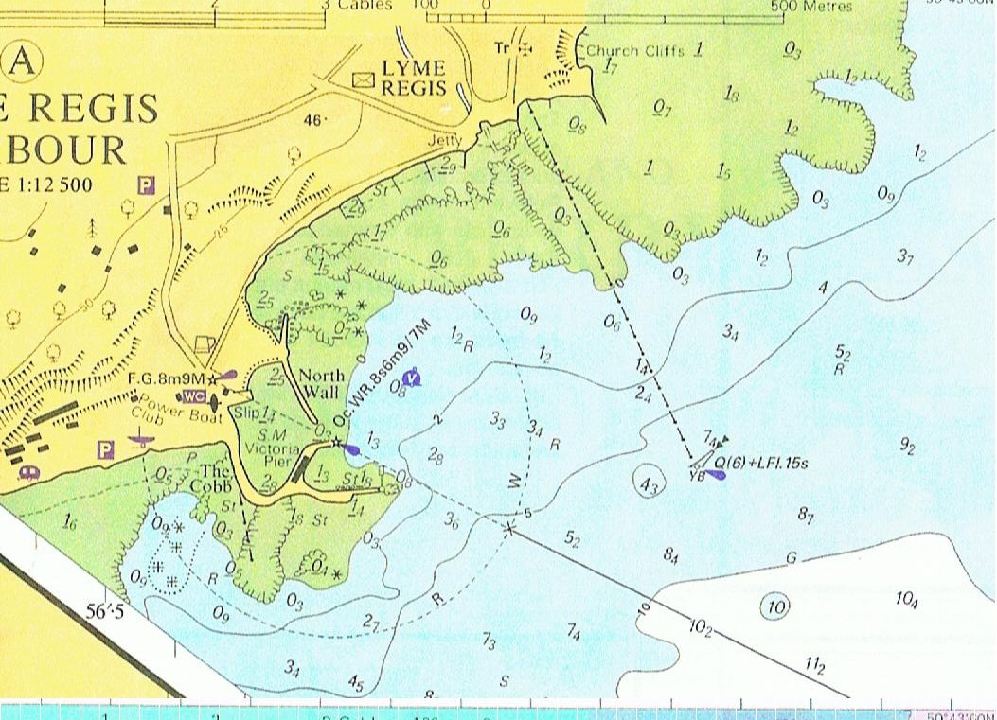
Original Prepared by: C F Spencer & Co Ltd

The Old Malt House
West Street
Banwell
Somerset
BS29 6DB

Latest Revision December 2018:
Grahame Forshaw (Harbour Master)
Amendment: 5.6 – Pontoon
Reviewed By James Radcliffe (Interim Harbour Master)
August 2019

CONTENTS
1 The Port of Lyme Regis 7
1.1 General Description 7
Photograph 1 View to seaward across the harbour at low water 7
1.2 Harbour limits 8
Figure 1 8
1.3 Anchorages 8
1.4 Ship parameters 8
1.5 Designated Nature Conservancy Sites 9
1.6 Port Users 9
Photograph 2 The 'trot' arrangement of boats 9
1.7 Statutory Authoirty 9
1.8 Legal Duties and Powers 9
1.9 Enabling Legislation 10
1.10 By Laws 10
1.11 Harbour Rules 10
1.12 Directions 10
1.13 Harbour Revision Orders 10
1.14 Accountability 10
1.15 Nominated Responsible Body 10
1.16 The Designated Person 10
1.17 Professional Staff 10
2 LEGAL STRUCTURE; PROFESSIONAL STAFF; POLICY 11
2.1 Statutory Authority 11
2.2 General Managmenet Policy 11
2.3 Marine Safety Policy 11
2.4 Systems and Standards 12
2.5 Consultation 12
2.6 Key Performance Indicators 12
2.7 Operation 12
2.8 Conservancy 12
2.9 Hygrography 12
2.10 Emergancies 12
2.11 Consultation 13
2.12 Consultation 13

3 Safety Management System 13
3.1 Introduction 13
3.2 Safety 13
3.3 Lines of Authority 13
3.4 Structure of the Safety Management System 14
3.5 Free-Standing Plans Now Adopted Into the System 14
3.6 Integrigation of the Elements 14
Photograph 3 harbor mouth at half tide 15
4 OPERATIONS PLAN 17
4.1 Overview 17
4.2 Berth operators and private users 17
4.3 Freight 17
4.4 Leisure Uses 17
4.5 Moorings 17
4.6 Pontoons 18
4.7 Fishing Vessels 18
Photograph 4 Fishing boat discharging cockles at harbour mouth at low water 18
4.8 Charter Boats 18
4.9 Passenger Ships 19
4.10 Hazardous Goods 19
4.11 Port management and marine safety 19
4.12 Overview of Port Movement Control 19
4.13 Communications 19
4.14 Collision Regulations 19
4.15 Speed Limits 19
4.16 Vessel Traffic Service (VTS) 19
4.17 Pilotage 20
4.18 Passage Plan 20
4.19 Training and Qualifications 20
4.20 Dangerous Vessels 20
Photograph 5 Rear of Cobb wall in outer basin showing original construction 21
4.21 Wrecks 21
4.22 Conservancy 22
4.23 Standards and Inspection of Aids to Navigation 22
4.24 Dredging, Hydrography and Admiralty Charts 22
Photograph 6 West side of the Cobb wall showing modern constuction 23

4.25 Meteorology 23
4.26 Tugs 23
4.27 Works Licensing 23
4.28 Event Management 24
4.29 I S P S 24
5 FORMAL RISK ASSESSMENT 25
5.1 General Commentary 25
5.2 Methodology 25
5.3 The ALARP Principle 25
5.4 Definitions 25
5.5 Risk Level Assessment 25
5.6 Oil Pollution 26
5.7 Other Emergency Response Plans 26
5.8 Recent Events 26
5.9 List Of Hazards Identified 26
5.10 HAZARD ONE: Harbour mouth 27
5.11 HAZARD TWO: the ‘Thunderbore’ 27
5.12 HAZARD THREE: extreme winter weather 28
5.13 HAZARD FOUR: vessels refuelling 29
Photograph 7 Fishermen’s shelter at the end of the Cobbs pier. 30
5.14 HAZARD FIVE: fire 30
5.15 HAZARD SIX: Moving craft on slipways and in boat parks 31
5.16 HAZARD SEVEN: The Harbour beach area and swimming 32
Photograph 8 View across the harbour with sandbank visable in the centre 32
5.17 HAZARD EIGHT: loading and unloading goods 33
5.18 HAZARD NINE: Passengers embarking and disembarking 33
5.19 HAZARD TEN: Persons falling from Piers 34
6 EMERGENCY RESPONSE PLAN 34
6.1 Assigned Areas Of Responsibility 34
6.1.1 All vessels in the harbour approaches 34
6.1.2 Craft in the harbour 34
6.1.3 All craft alongside in the harbour 34
6.2 SOSREP 35
6.3 THE PLAN 35
6.3.1 General 35
6.3.2 Pollution 35
6.3.3 Tug and Salvage Equipment Availability 35
6.3.4 HM Coastguard 36
6.3.5 R N L I 36
6.3.6 Vessels Aground 36
6.3.7 Wrecks 36
6.3.8 Persons in Difficulties in the Water 36
7 REPORTING, ASSESSMENT AND AUDIT 37
7.1 Overview 37
7.1.1 External Reporting 37
7.1.2 Internal Reporting Chain 37
7.2 Continuous Assessment 37
7.3 Investigation and Reporting 38
7.4 The audit trail 38
7.4.1 Introduction 38
7.4.2 Twelve-Monthly Review 38
7.5 External Reporting 39
7.6 Reporting Of Incidents, Accidents or Disasters 40
7.7 Internal Investigation and Reporting 40
7.8 Reporting 40
7.9 Public Scrutiny 40

The Port of Lyme Regis

General Description
Lyme Regis harbour lies in 50° 43’N, 002° 56’W, about half way along the Lyme Bay coast. It is a very ancient harbour with recorded activity dating back to the twelfth century, and was once one of the foremost ports in England. Those days are long gone, however, and now the harbour accommodates small fishing boats and yachts. It consists of a substantial Western breakwater, the Cobb, with Victoria Pier branching from this to the East. These, along with the detached North Wall, form a basin which constitutes the harbour. The landward side has been filled in by a substantial sand bank which now links the North Wall with the Cobb and the shore; this beach is very popular with the public.
Formerly, Cobb was a separate village which gave its name to the harbour; nowadays it is incorporated into Lyme Regis although still somewhat detached geographically. The Cobb breakwater itself is now a Grade 1 listed structure. The harbour dries at low water except for a pool of deeper water in the harbour mouth which allows shallow draft craft to remain afloat at the passenger steps.
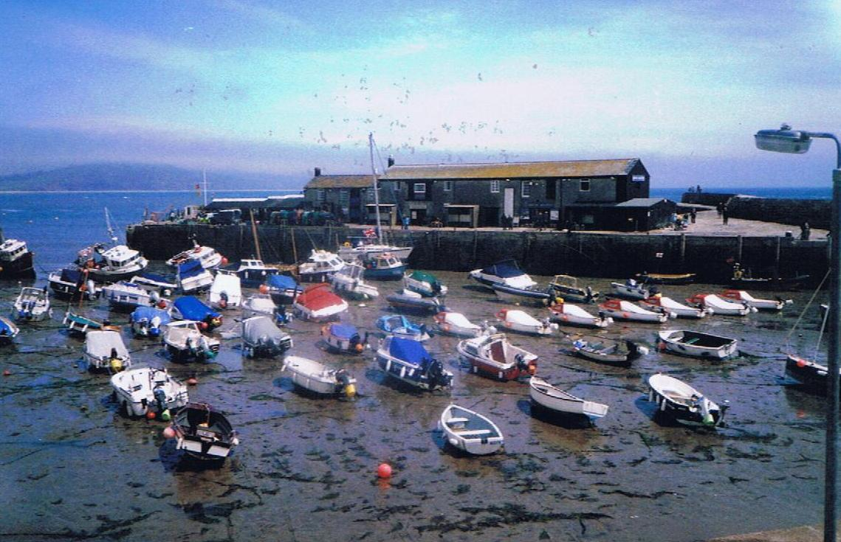

Photograph 1 View to seaward across the harbour at low water

Harbour limits

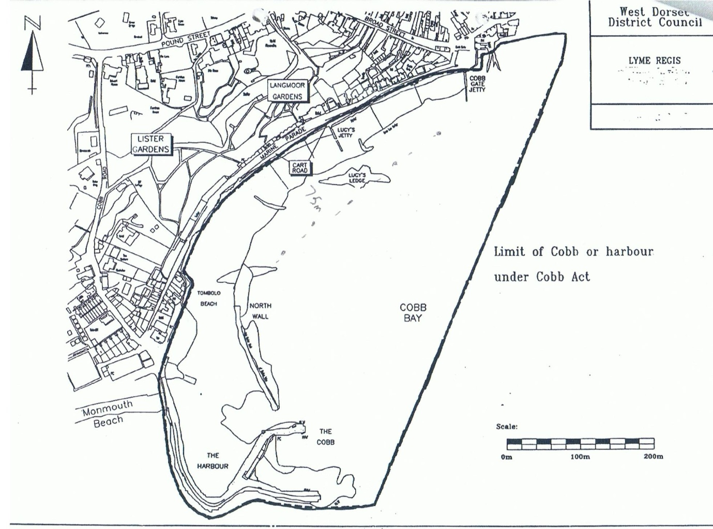

Figure 1
The tidal range at Lyme Regis is 4.5m at maximum spring tides, 1.0m at slackest neaps.

Anchorages
There are no designated anchorages at Lyme Regis.
The bay area is completely open from South-East through South to West and offers no shelter to weather from those sectors. A choppy sea can get up very rapidly in Lyme Bay when the wind rises from an exposed quarter.
At Lyme Regis, small vessels can anchor 900m South East of the harbour entrance, but there is no shelter. In sailing ship days Lyme Regis harbour was a port of refuge for vessels embayed in Lyme Bay but unable to anchor due to stress of weather.

Ship parameters
At Lyme Regis, vessels up to 10m length, 3.8m beam, and 2m draught are regarded as the maximum size nowadays, although larger coastal traders used the port in previous times.

Designated Nature Conservancy Sites
There are no designated nature conservancy areas within the Lyme Regis harbour limits. The entire coast from Sidmouth to West Bay/Bridport is an SSSI and much of it also an SAC. This is the famous ‘Jurassic Coast’ and is subject to tight controls on what is permissible.

1.6 Port Users
The harbour is normally taken up with small craft. Commercial users are small inshore fishing boats and charter boats but the main users are pleasure craft. The basin is entirely filled by these craft which virtually all lie to trots of moorings laid in the harbour.
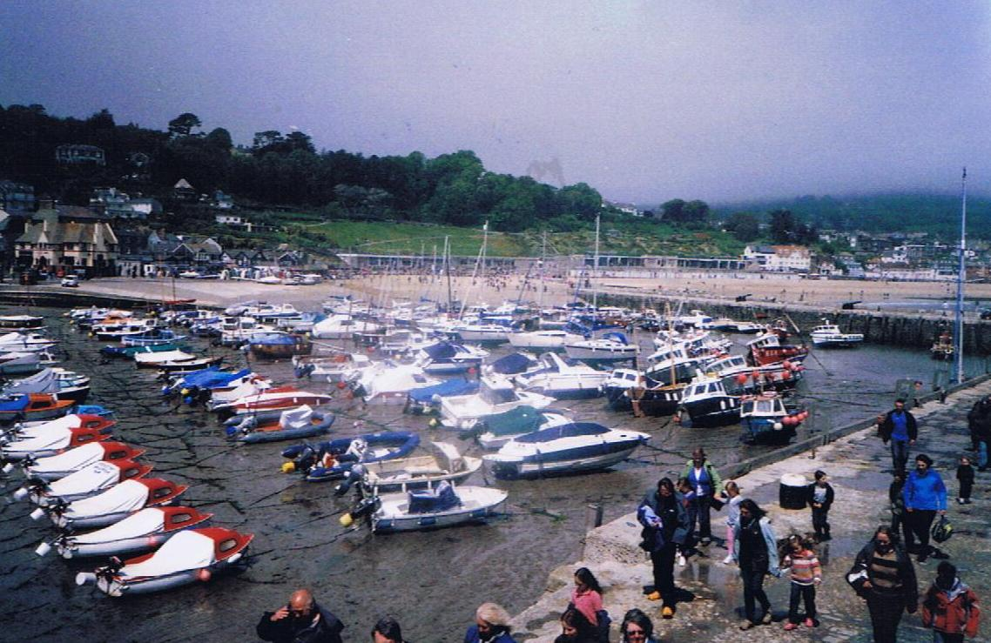
Photograph 2 View across the harbour towards the shore. The ‘trot’ arrangement of boats can be seen.

Statutory Authority
Dorset Council is the Statutory Harbour Authority (SHA) for Lyme Regis. Lyme Regis is not a Competent Harbour Authority within the meaning of the Pilotage Act 1987 but nevertheless conforms to the Port Marine Safety Code. The SHA is answerable to its electorate via the councillors both in direct approaches and at the ballot box.

Legal duties and powers
Lyme Regis is an open port, into which any user has a right to navigate on payment of harbour dues. There is a duty to operate it safely for the benefit of all such users. The berths and wharves and seasonal pontoons are under the control of the Harbour Master.

Enabling legislation
Lyme Regis operates under an act of 1821. This Act, a splendid piece of Georgian English. This Act confirms the status of an Act from the thirty-fifth year of Queen Elizabeth I’s reign, which appears still to have legal force.

By-laws
Lyme Regis Harbour has four sets of by-laws still current. In addition a general set of Dorset Council by-laws, mainly concerned with conduct on roads and in public places, has force in the harbour area.

Harbour rules
Boat owners at Lyme Regis are required to comply with additional rules; a copy is published on dorsetcouncil.gov.uk. These are largely taken up with rules for moorings.

Directions
There are no directions extant.

Harbour revision orders
There are no Harbour Revision Orders in force.

Accountability
The Dorset Council as the SHA is accountable for its duties and powers. Its discharge of this responsibility is measured against nationally agreed standards as laid down in the Port Marine Safety Code and amplified in the Code’s accompanying Guide to Good Practice.

Nominated responsible body
Under the terms of the Port Marine Safety Code, the Harbour Committee of Dorset Council is the Duty Holder.

The designated person
The Designated Person for Bridport, Lyme Regis and Weymouth harbour is William Heaps (Principle consultant at Marico Marine).

Professional staff
Dorset Council employs a Harbour Master and one full time assistant Harbour Master plus one part time Harbour assistant. Two further assistants are employed for the season. These staff members have day-to-day operational responsibility for the port.

Legal Structure; Professional staff; POLICY
As required by the “Code”, Dorset Council publishes its policies, plans and periodic reports, setting out how they comply with the Code’s standards and these are found below.
A document ‘Harbour Policy’ is also published on dorsetcouncil.gov.uk which regulates much of the activity in the harbour.

Statutory Authority
Dorset Council as the Statutory Harbour Authority (SHA) is committed to undertaking and regulating marine operations so as to safeguard the harbours, their users, the public and the environment.
The authority aims to run a safe, efficient, cost-effective, sustainable harbour operation for the benefit of all users and the wider community.
The authority aims to meet the national requirements in the Port Marine Safety Code, and fulfil its legal responsibilities whilst endeavouring to meet the changing needs of harbour users.

General Management Policy
The Council will support the commercial, fishing, and recreational activities in the harbours through the provision of appropriate services of good value.
The policy of the Council is to:
Manage the assets of the Authority safely, economically and efficiently.
Train the operational staff and ensure they are properly trained in emergency and contingency procedures.
Regulate traffic within the harbour limits to ensure safe and efficient movements.
The SHA and its authorised officers are aware of their environmental commitments. Although there are no designated conservation areas within the harbour limits, the local environment of both ports is considered important and the impact on it will be a material consideration if any changes to the existing situation are proposed.

Marine Safety Policy
The Council and its staff will ensure marine safety by:
Providing a safe environment for navigation through aids to navigation and conservancy.
Regulating activities within the port as required by statute.
Training and educating staff, users and the public in safety awareness.
Ensure as far as reasonably practicable the safety at work of its employees and other people who may be affected by its activities.
Application of the Port Marine Safety Code and its supporting Guide to Good Practice through this Marine Operations Plan.

Systems and Standards
The plans established in this document have been developed on the basis of a formal risk analysis, and a Safety Management System evolved in response to that risk analysis. It is based on the “As Low As Reasonably Practicable” (ALARP) principle, which aims to reduce risk levels to the lowest practical level.

Consultation
Representatives of all regular user groups were consulted in the creation of this Code. Provision is made under the continuous assessment procedure for any change which affects a consultee to be consulted before or at the time of any such change.
In the course of preparation of the PMSC Plan for Lyme Regis, the following were consulted:
Harbour Staff
Fishermans’ Association
Lyme Regis Sailing Club
Lyme Regis Power Boat Club

Key Performance Indicators
Dorset Council considers the following key responsibilities apply to its ports, all of which conform to the best practice requirements of the Port Marine Safety Code and its appending Guide to Good Practice.

Operation
To operate the port and regulate vessel movements for a 100% incident-free service.

Conservancy
To maintain and operate all navigation marks and lights to at least IALA standards, and conform to Trinity House reporting procedures.

Hydrography
The Harbour will be surveyed as and when necessary, by professional surveyors. Where appropriate the results will be notified to the Hydrographer of the Navy.

Emergencies
To carry out one major exercise per year.
To ensure on-going training is maintained in all emergency procedures at the port.

Consultation
Both commercial and leisure user representatives meet at the annual harbour users’ meeting in September/October, but the Harbour Master is available on a daily basis to discuss with boat owners and operators any areas of concern.

Audits and Continuous Assessment
Ensure continuous assessment is carried out with periodic internal reviews of all port functions.
Carry out a full formal audit at not more than three year intervals, of all port functions and report the results publicly.

SAFETY MANAGEMENT SYSTEM

Introduction
The Port Marine Safety Code requires that each port’s powers, policies, plans, and procedures must be based on a formal assessment of hazards and risks. Harbour authorities must have formal safety management systems.
To comply with this, the hazards within the port of Lyme Regis have been identified, the risks associated with each evaluated, and the element of the Safety Management System which applies to that risk described.

Safety
Safety is not a separate discipline isolated from the workings and day-to-day life of a port. The full and proper application of safety measures allows an incident-free and safe working environment in which ships go about their business without hazard.
The objective of the Port Marine Safety Code is to ensure that every element in a port’s operation follows the same unitary system of safe working practices, and that working within this Code is automatic and embedded in the way everyday activities are carried out. To this end it prescribes lines of authority, actions to be taken, and the way in which the port’s activities are to be carried out to achieve that level of safety.
Within the Marine Operations Plan for each port, safety has been integrated at all levels.

Lines of Authority
The Port of Lyme Regis has a simple and effective line of authority. The ports are managed by Dorset Council’s Head of Environment and Wellbeing. The Head of Environment and Wellbeing reports to the Duty Holder normally via the Environment Overview and Scrutiny Committee but directly if necessary. The Head of Environment and Wellbeing has practical responsibility for both ports.
The port has a Harbour Master who reports to the Head of Environment and Wellbeing. The Harbour Master manages and regulates the port and all movements into and out of it. There is an assistant Harbour Master to give general help in the running of their port, plus one full time part time harbour assistants.
The Duty Holder is the Harbour Committee of Dorset Council.

Structure of the Safety Management System
The Safety Management System provides a framework for the operation of the port and is in three parts:
Port Procedures: The port procedures lay down the practical day-to-day working practices of the port.
Risk Assessment: The Formal Risk Assessment identifies and grades the risks likely to occur within both ports.
Response Plan: Responds to risks identified in the formal risk assessment.

Free-Standing Plans Now Adopted Into the System
There are three plans adopted into the Safety Management System:
- Dorset Council Civil Emergencies Plan.
The Dorset Council Emergency Plan lays out the systems to be used for any emergency in the district. Should any incident in the harbour area have consequences reaching beyond its confines, it is the regional plan which will be brought to bear.
- Coastal Oil Pollution Response Plan.
The ports are below the size limit for the requirement to have individual oil pollution response plans, but are party to the Dorset Coastal Plan.
- Waste Management Plans.

There is a Dorset Council waste management plan, See link below:
https://www.dorsetcouncil.gov.uk/countryside-coast-parks/harbours-and-quays/pdfs/port-waste-management-plan.pdf

Integration of the Elements
Only a limited number of people are involved in running the port: there is a clearly defined senior officer, the Harbour Master, in charge of all practical marine matters. His reporting line is also short and clear, and hence the scope for uncertainty or confusion is minimised.
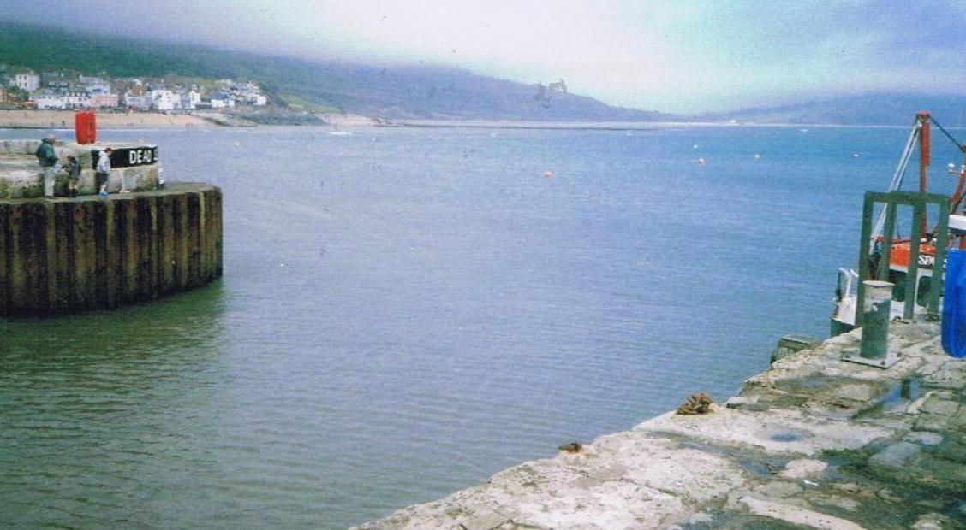

Photograph 3 Harbour mouth at half tide

OPERATIONS PLAN

4.1 Overview
The operations plan for Lyme Regis is based on the port being used entirely by small craft, many of them local, which are both manoeuvrable and familiar with the port. Therefore major structured arrangements and plans are not needed to ensure safe navigation. Despite this, the port has its own demands and it is necessary to have a plan to accommodate these, and to keep the disparate users of the port from causing problems for each other.

4.2 Berth operators and private users
The owner of any vessel using the harbour shall ensure that whoever has charge of his craft is familiar with, and complies with, the conditions of mooring and any other harbour regulations from time to time in force.

4.3 Freight
There is no freight traffic in Lyme Regis.

4.4 Leisure Uses
Lyme Regis is primarily a leisure harbour nowadays. It has around 240 pleasure craft moorings and about 100 sailing dinghies frequently launched to race in the Bay. Lyme Regis also has extensive visiting leisure traffic with around 400 visiting yacht calls each year. During the peak period in July and August there can be several hundred small craft movements per day, comprising local charter boats, visiting yachts, powerboats, and many small inflatables. A dry storage for 100 kayaks is also provided.

4.5 Moorings
Lyme Regis harbour is extensively filled with 240 moorings. These are strictly controlled by the Harbour Masters on behalf of Dorset Council, which has the sole authority to authorise moorings. Most moorings in both harbours are in trots, laid to ground chains across the harbours. Both the ground chains and risers are provided by the Council, boat owners providing their own rope attachments. Ground chains and risers are inspected annually by the Harbour Masters and their staff, it being the Council’s responsibility to maintain these. The upper parts of moorings are the responsibility of the berth holder. The upper parts are removed at the end of the season and small pellet buoys put down instead. Chains have to be renewed at regular intervals, typically every 3 to 4 years.
Moorings are allocated annually giving priority to existing mooring holders, then to Dorset Council ratepayers on the waiting list. Controls are in place to ensure fair allocation.
Launching slips are provided and are supervised by the Harbour Masters. At Lyme Regis, there is a boat lifting trailer with tractor which can pick up boats, launch, recover and attach them to moorings, operating over the harbour bed at low water. There is a charge for this service.

4.6 Pontoons
A pontoon facility is provided in the Pool area close to the South outer protection wall on a seasonal basis (normally April to September). The pontoon is a system made of modular plastic construction and is secured to the seabed with chains and weights. There are four fingers the seaward end of which are lit (White, 1 flash every 10). Caution is advised because of varying depths at low water. Visitors are advised to seek confirmation of available water before mooring.

4.7 Fishing Vessels
There are 20 commercially-operated fishing boats based at Lyme Regis, of which 3 work as inshore trawlers, and the remainder as pot boats, with some conversion between trades to suit the seasons. All are of modest size and only operate on a day-trip basis. These craft are all licensed now by the MCA according to the latest Code of Practice. Catches are landed for immediate transport to market, each fisherman being responsible for unloading and transportation. Lyme Regis boats sometimes land their catches at Bridport.
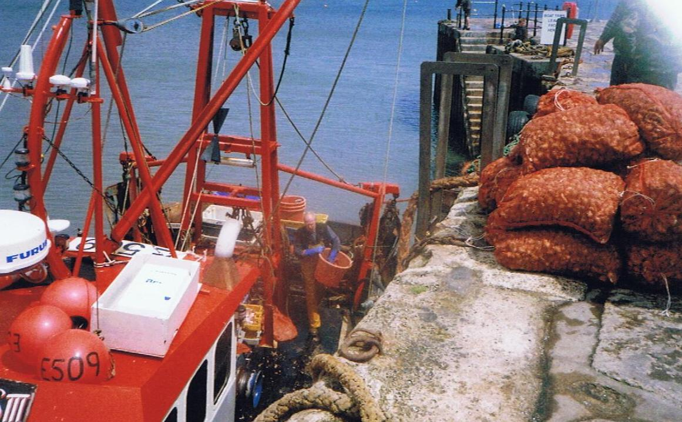

Photograph 4 Fishing boat discharging cockles at harbour mouth at low water

4.8 Charter Boats
There are 14 trip charter boats licensed to operate from Lyme Regis. These variously provide fishing/educational trips round the bay, sea angling, and diving activities. The majority remain close to the shore. All are MCA licensed under the latest Codes of Practice. There is some overlap between operating as commercial fishing boats and as day charter fishing boats, 2 boats have dual licenses.

4.9 Passenger Ships
Lyme Regis infrequently receives passenger cruise liners, It is hoped that the port could become a regular part of the Cruise liner itinerary.
In addition, day trip charter boats take ‘round the bay’ excursion traffic.

4.10 Hazardous Goods
Apart from small quantities of fuel for the port’s boats, no hazardous goods are handled at either port.

4.11 Port management and marine safetyt

4.12 Overview of Port Movement Control
Very largely, traffic movement is left to the skippers of craft on the move. At Lyme Regis more direct intervention by harbour staff is necessary at peak times, as many people unfamiliar with the harbour, and indeed unfamiliar with boat handling, use the harbour at these times.
The Harbour Master has reserve rights to direct vessel movements and determine priorities when the need arises. Given the excellent safety record of the port there seems little point in changing the simple direct intervention methods which have been so effective.
When required, navigation control is carried out by the Harbour Master or his assistants by direct intervention from their patrol boats, the quayside, or by VHF radio. There are no formal navigation control centres. The port is equipped with a fast patrol boat, used both within the harbours and to police the beaches and inshore waters around the harbour.

4.13 Communications
When the Harbour Master is in attendance he listens and works on VHF Channel 16 and Channel 14.

4.14 Collision Regulations
Vessel movements are carried out in conformity with the provisions of the International Regulations to Prevent Collision at Sea, 1972, as amended.

4.15 Speed Limits
A speed limit is in force within the harbour at Lyme Regis. ‘Dead slow’ is the requirement with an understanding that this means minimum steerage way.

4.16 Vessel Traffic Service (VTS)
There is no VTS service at Lyme Regis.

4.17 Pilotage
There is no pilotage service at Lyme Regis except by request. The harbour is not a CHA, and has no duty to provide pilots.
No pilots are authorised; should any vessel request the services of a pilot at either port, the harbour master could go ahead of the incoming vessel in his RIB, to be followed.
Advice and guidance is given by VHF to larger craft coming to anchor outside the harbour.

4.18 Passage Plan
As there is no pilotage service, there is no requirement for a formal passage plan into the harbour to be in place. A pilotage plan for large vessels coming to anchor has been drawn up. The Harbour Master will give advice to visiting craft on request.

4.19 Training and Qualifications
The SHA requires its Harbour Master to have had suitable harbour experience.
Each year one aspect of the port’s emergency response regime should be subject to a full-scale response exercise and the other aspects are subject to refresher training with all relevant equipment surveyed and checked as necessary.
The Council operates a staff appraisal scheme when the training, further qualifications, or revalidation needs of all staff are assessed.

4.20 Dangerous Vessels
The Dangerous Vessels Act of 1985 defines a dangerous vessel as:
1) One which poses a grave and imminent danger to the safety of any person or property within the port;
2) One which may, by sinking or foundering in the harbour, prevent or seriously prejudice the use of the harbour by other vessels.
Harbour Masters have powers to deal with such vessels and may give orders to the owner, master, or any other person, including a salvor, who may be in charge of such a vessel.
If it is practicable to do so, the first step should be to require the person in charge of a dangerous vessel to make it safe immediately. If they are unwilling or unable to do so, the Harbour Master may take steps himself to make it safe or to remove it, having a usual lien over the ship for the cost of doing so.
In many cases a vessel will become dangerous very rapidly and leave no time for considered action. The port’s emergency plan must be initiated, according to the problem the dangerous ship has. The Harbour Master’s duty is to protect life and property, while ensuring that his port can continue to operate.
A port is not bound to accept from sea a dangerous vessel which requests entry, but the 1985 Act states that in making a decision the Harbour Master must have regard to the safety of any person or vessel, whether in or outside the harbour.
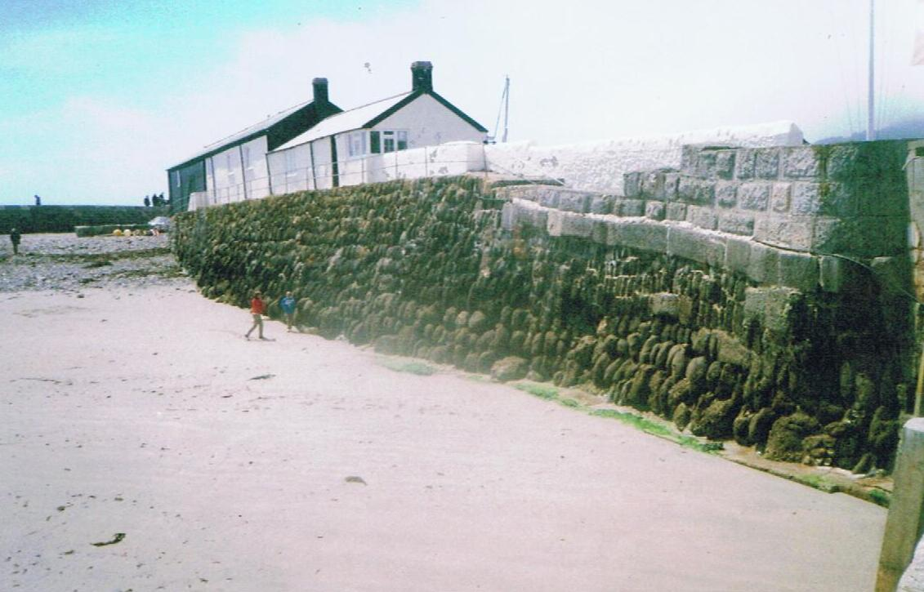

Photograph 5 Rear of Cobb wall in outer basin showing original construction

4.21 Wrecks
There are no wrecks close to Lyme Regis harbour.
Port authorities have a common law duty to ensure that their harbours are safe for navigation and, equally, to warn ships using the harbour of any hazards within its port. Wrecks are an important consideration within this duty.
In the first instance, any body having control of a wreck has a duty to remove it and Harbour Master is entitled to demand that it be removed forthwith.
That said, Harbour Masters have powers to deal with any wrecked vessel which is, or is likely to become, an obstruction or danger to navigation or to lifeboats within his port or its approaches.
These powers are:
(a) To take possession of, and raise, remove, or destroy the whole or any part of the vessel and any other property to which the power extends;
(b) To light or buoy the vessel or part of the vessel and such other property until it is raised, removed or destroyed.
Beyond this, the Secretary of State has general superintendence throughout the United Kingdom of all matters relating to wreck. He is entitled to appoint a special representative (SOSREP) to exercise those powers on his behalf, or to appoint a Receiver of Wreck. The Secretary of State may appoint a representative to take control of any incident, whether within a port or not, and Harbour Masters are required to co-operate in dealing with the incident.
SOSREP has a particular brief to prevent or control pollution and is most likely to take charge when pollution may be involved, but his derogated powers are not limited solely to this area.

4.22 Conservancy
At Lyme Regis, a set of leading lights bearing 284° (T) leads clear of the outer breakwater end and into the harbour. It is provided by two lights, the rear being a fixed green light visible 9 miles, the front an occulting sectored light showing red from the leading line to the South and West, white to the North and East. All permanent navigation lights at both ports are powered by mains electricity without emergency back-up, but as both ports are very largely daylight only operations, this is not considered to be a major problem.
A buoy has been installed outside Lyme Regis harbour entrance, to mark the end of a new sewer outfall. This is a south cardinal buoy, showing a standard flashing white light, in position 50° 43.17’N, 002° 55.66’W. Although not intended as such, it can be a useful fairway buoy for incoming small craft.

4.23 Standards and Inspection of Aids to Navigation
Dorset Council aims for a minimum of IALA standards, which for its ports is category two. Dorset Council is a local light authority and its aids have been subject to an annual inspection by Trinity House. The Panar system is in operation to cover the rest of the year.

4.24 Dredging, Hydrography and Admiralty Charts
Dredging at Lyme Regis is carried out each year in its approaches, and from time to time within the North East and South West corners of the harbour where a bank of silt and sand tends to build up. The South West bank is allowed to remain as much as possible as it gives good protection to that corner from more extreme weather. The main part of Lyme Regis harbour bed is firm and stable, and does not require attention.
Lyme Regis harbour is surveyed twice a year, at the same time as Bridport, by a launch from the firm Shoreline Surveys. It examines the harbour and the sea bed out the harbour limit. The surveys are done pre and post dredging. Any major changes are notified by a Notice to Mariners with a copy to the Hydrographer of the Navy.
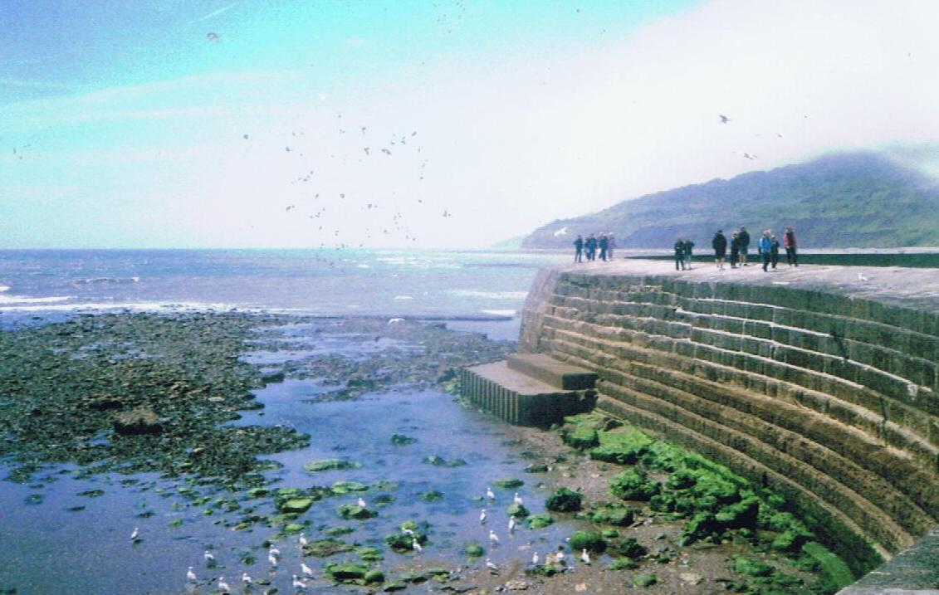
Photograph 6 West Side of Cobb wall showing modern construction. This section takes the full force of gale seas from the West

4.25 Meteorology
Lyme Regis can be seriously affected by the weather. Lyme Bay is open to the Atlantic from the South-West quadrant, and very large seas can buffet both ports in strong gales. In addition, any wind from the south can very quickly kick up a short sea uncomfortable for small boats.
Green seas come right across the Cobb from time to time in severe weather. The Harbour Master is entitled to fly a red flag from the yacht club’s flagpole on the end of Victoria Pier when launching is prohibited. He can fly the hoist RY to slow vessels down.
Lyme Regis is less affected by weather from the SW than Bridport; therefore if any boats at sea are unable to make Bridport, it is usually possible to shelter in Lyme Regis.
Movement is considered to be largely self-regulating: the boats only operate by day and if bad weather is expected imminently, or the entrance is difficult of exit, boats do not go out and hence the need to provide protective measures for craft struggling to make the entrance is minimised.

4.26 Tugs
There are no tugs available at Lyme Regis, the nearest source being Portland or, for a smaller tug, Weymouth. See Emergency Plan.

4.27 Works Licensing
All Major works in both ports are either carried out by direct labour of Dorset Council, or by contractors directly controlled by the Engineering Division so the need for licensing is minimised. Works carried out are agreed with the Harbour Master and controlled by the Principal Engineer in consultation with Dorset Council officers. It is rare, other than dredging, for such works to affect navigation. Minor works may be carried out directly by the harbour master or his assistants.

4.28 Event Management
Lyme Regis hosts many events through the year, and an informal level of risk analysis, along with a high degree of organisation, has always gone into planning these events.
The ‘Guide to Good Practice’ annexed to the Port Marine Safety Code requires risk analysis to be carried out fully by the organisers before any event is allowed to go ahead, and the results of the risk analysis must be given to the Harbour Master.
In turn the Harbour Master must be satisfied that the event meets the requirements of the Coastguard, the RNLI, and the shore-based emergency services. Where a national body represents the type of craft taking part in an event, any guidance or code provided by that body should be adhered to.
It is up to the organisers of each event to carry out their risk assessment of their event. The Harbour Authority ‘notes’ each risk assessment presented by the organisers of events, and unless it chooses not to approve them they can go ahead. It is normal for events to be insured and it is felt that, providing the insurers are willing to accept and underwrite the event, this should be enough for the Harbour authority.
When submitting their risk analysis, event organisers must also advise:
Names of event organisers and officials;
List of participants;
List of authorities consulted;
Timetable and programme of events;
Arrangements for controlling the event, including any special communications;
Any navigational constraints being imposed such as restricted areas or partial port closures;
Emergency arrangements;
Media arrangements.
This listing goes to the Dorset Council’s Property Services team.
Any additional resources required from the Harbour Master, the Council or the emergency services will normally be at the expense of the event organiser.

4.29 I S P S
The Department of Transport Certificate of Port Facility Plan has been placed on retention since cruise liner traffic has significantly reduced.

5 FORMAL RISK ASSESSMENT

5.1 General Commentary
The port of Lyme Regis has a long history of offering shelter to vessels in the Eastern half of Lyme Bay where, especially in sailing ship days, they could all too easily become embayed. To fulfil this function it had to be a safe, reliable harbour easy of access. It remains so today, and in general can be assessed as a low risk port. There are certain features which can be problematic: it is a drying harbour, so not so accessible around low water. In winter, green seas can break right over the Cobb and cause disturbance in the harbour basin. It is also a very popular multi-use facility which can cause passing problems from time to time. As the Harbour Master or a deputy is often on his own at weekends, much of his time is taken up with practical accident prevention and general supervision in the harbour.

5.2 Methodology
This risk assessment has been carried out by Captain Douglas J Lindsay, in association with Grahame Forshaw, former Harbour Master of Lyme Regis. Each risk has been identified and assessed, with the response to it considered and described. It is believed that all significant hazards and the risks following from them have been identified. Some very minor risk were considered but not felt to be of sufficient consequence to justify individual treatment.

5.3 The ALARP Principle
In planning and organising its safety systems the port has applied the ‘ALARP’ (As Low As Reasonably Possible) principle by working to a fundamental basis of keeping different user groups apart as far as reasonably possible.

5.4 Definitions
The Port Marine Safety Code defines:
Hazard is something which has the potential to cause harm.
Risk is a combination of frequency of occurrence and consequence (outcome).
For analysis purposes the following definition has also been adopted:
Control Measures are objects or systems put in place singly or in combination, to mark hazards and control risks.

5.5 Risk Level Assessment
Each hazard identified is assigned a three-word risk level assessment Viz. Low/Medium/High. Of these the first is an assessment of the
Likelihood, (indicated ‘L’ on individual Risk Level Assessments), of the event occurring.
The second is an assessment of the Consequences, (indicated ‘C’), if it should occur.

5.6 Oil Pollution
No specific mention is made in this risk analysis of oil pollution, as the port is below the size to require a full pollution plan if its own. The regional plan, applying to the entire coast in the region, does apply and this is subject to being re-written in 2012 following an exercise.

5.7 Other Emergency Response Plans
For complete emergency response, this plan should be taken in conjunction with the Dorset Council’s regional emergency response plan.

5.8 Recent Events
In 2011 a person in a mobility powered wheelchair appeared to lose control while waiting to board one the harbour’s local leisure trip boats. This wheelchair ran forward, tipped over the edge of the quay, and the person subsequently drowned despite immediate efforts to rescue her as she was strapped into her wheelchair and went down with it. Doubts about how and why this happened have remained, but careful investigation has not produced an answer or any safety measures which could prevent such an incident without destroying the entire open quay ambiance of the harbour.

5.9 List of Hazards Identified
- Harbour Mouth
- The ‘Thunderbore’
- Extreme Winter Weather
- Vessels Refuelling
- Fire
- Moving craft on Slipways and in boat parks
- The Harbour Beach area and swimming
- Loading and unloading goods
- Passengers embarking and disembarking
- Persons falling from piers.
5.10 HAZARD ONE Harbour Mouth
The Lyme Regis harbour entrance presents little problem to any one vessel, its only obstruction being shoal patches immediately outside the harbour. But in summer time, it can become severely congested with trip boats, racing dinghies, visiting craft from seaward and launched from trailers, and the local fleet of fishing boats and yachts, all on the move. Up to 200 craft movements a day are reported at peak times.
RISK 1a: Collision and interference between boats becomes a significant consideration in the summer season. With highly disparate types of craft and levels of skill, the scope for accidents is considerable.
RISK 1b: Following collision or interference, there is a risk of a damaged craft sinking in the entrance, thereby adding to the congestion.
RISK 1c: Following collision or interference, the risk also exists of persons ending up in the water. With many other craft around, including the Harbour Master’s launch, rescue should be swift, but the risk to persons in the water from propellers and other vessels is significant.
RISK ASSESSMENT LEVEL:
L: Low/Medium
C: Medium/high
RESPONSE:
a) During the peak summer season the Harbour Master or his assistant is active in the area of the harbour mouth, to keep order among the many conflicting uses of the area.
b) Speed limits and correct boat handling are strictly enforced.
c) Harbour staff are trained in the rescue of persons from the water, and their treatment when rescued.
5.11 HAZARD TWO: the ‘Thunderbore’
The Thunderbore is the local name for an unusual phenomenon at Lyme Regis. It is the product of tidal harmonics and certain meteorological circumstances usually associated with bad weather from the South and a rising tide (although it can also occur on the ebb). A swirling current will enter the harbour mouth and rotate strongly in an area inside the North Wall. While this is going on the tide will rise half a metre higher than normal. The whole episode occurs two and a half hours before low water, lasts about forty minutes before dying down again, with the water level falling back to its normal prediction. The Thunderbore occurs four or five times a year.
The Thunderbore has been known about and coped with for a very long time, and the harbour staff and users know how to deal with it. Its potential is considerable for causing problems to people unfamiliar with it.
Thunderbores appear at other places along the South coast as far West as Cornwall and are a regular feature of life in the area. But the one inside Lyme Regis harbour is particularly strong and particularly public.
RISK 1a: The Thunderbore sets up strong currents which could cause problems to anyone not accustomed to the event, as it is strong enough to throw small boats about in an unpredictable way.
RISK 1b: Three fishing vessels lie to swinging moorings in the area the Thunderbore moves in, as any vessels secured fore and aft would be buffeted very badly. By being able to swing to their moorings these boats can stay head to the current, and are described as “swinging wildly round and round” during the episode.
RISK 1c: Anyone in the water who got caught in the Thunderbore would be in serious difficulties, even if they were a strong swimmer.
RISK ASSESSMENT LEVEL:
L: Certain
C: Medium, potentially high
RESPONSE:
a) Warn any strange craft to keep well clear, with a ‘clear the area’ warning if the Thunderbore is observed to be starting.
b) Local users are used to the phenomenon and know to keep clear when it starts.
c) The three fishing boats with moorings in its area are properly equipped, strong seagoing vessels, able to cope with its effects. Their swinging moorings are extra strong.
5.12 HAZARD THREE: extreme winter weather
Although the Cobb breakwater provides good shelter for the harbour, there is nothing unusual about heavy seas breaking right across the top of it into the harbour during strong South-westerly gales associated with particularly high tides.
RISK 1a: Vessels lying afloat to moorings when such extreme weather arises may get into difficulties, with heavy seas buffeting them and the danger of their moorings parting and of being washed ashore.
RISK 1b: The Cobb is open to the public, and there is always the risk that some foolhardy soul may try to drive or walk along it with seas breaking over it. Their survival chances if they do are not good.
RISK 1c: Under these conditions harbour operations are suspended. Although no longer as important as it used to be as a harbour of refuge, denial of entry could still make the difference between survival or not for a vessel in difficulties or distress outside.
RISK ASSESSMENT LEVEL:
L: High
C: Low/medium
RESPONSE:
a) There is usually a good warning forecast of extreme weather coming, and preparations can be made in the harbour to secure boats and double moorings.
b) When conditions merit (generally a gale warning in force) the Harbour Master may fly a red flag from the sailing club’s mast on the Victoria Pier end. This would not necessarily deny entry to a vessel in extremis outside the harbour, but advises any commercial vessel against operating.
c) Private moorings are let for the summer season only, from 1st April (or Easter if earlier) to the end of September. The season may be extended at the Harbour Master’s discretion. Only commercial boats are allowed in the harbour over the winter months when the risk is greatest.

5.13 HAZARD FOUR: vessels refuelling
The permanently-based craft at Lyme Regis refuel either from drums brought in on road transport, or from tanks in the fishermen’s stores.
RISK 1a: Fire: Not a major risk on the quayside as the fuel is almost entirely diesel, but a risk is always present where combustible materials are handled.
The petrol handled is 2-stroke mixture for outboard engines, which comes in fuel tanks in small quantities.
RISK 1b: Oil pollution: Not a major risk as quantities tend to be small and the oil is light fractions which disperse readily. Refuelling is a frequent occurrence.
RISK 1c: Injury or contamination of bystanders and the general public. All Lyme Regis’ quays are open to the public, and refuelling goes on in their midst.
RISK 1d: There is a particular risk associated with refuelling at Lyme Regis. Some of the fishermen have bulk diesel storage tanks in their gear sheds and these tanks are surrounded by highly combustible nets, ropes, paint and other materials. While the risk from diesel to the stores is low, the risk is of the other stores catching fire and ultimately setting the diesel tanks alight.
RISK ASSESSMENT LEVEL:
L: Low
C: High
RESPONSE:
a) Naked flames and smoking should be prohibited, and equipment used should be correct for the purpose and be fire resistant. Bystanders should be kept back from the working area.
b) Remove other craft in the vicinity to create a fire break around the vessel on fire.
c) The fuel tanks inside the fishermen’s’ stores should be surveyed regularly by the local fire brigade and/or Council officers.
COMMENTARY
The fishermen’s fuel tanks have replaced by bunded ones in recent times, making the much safer. The sheds have been re-wired to reduce the danger from electrical fires, and inconsequence more bulk supplies are being delivered. The Cobb, however, is subject to a seven and a half tonne weight limit which limits the quantities which can be delivered.
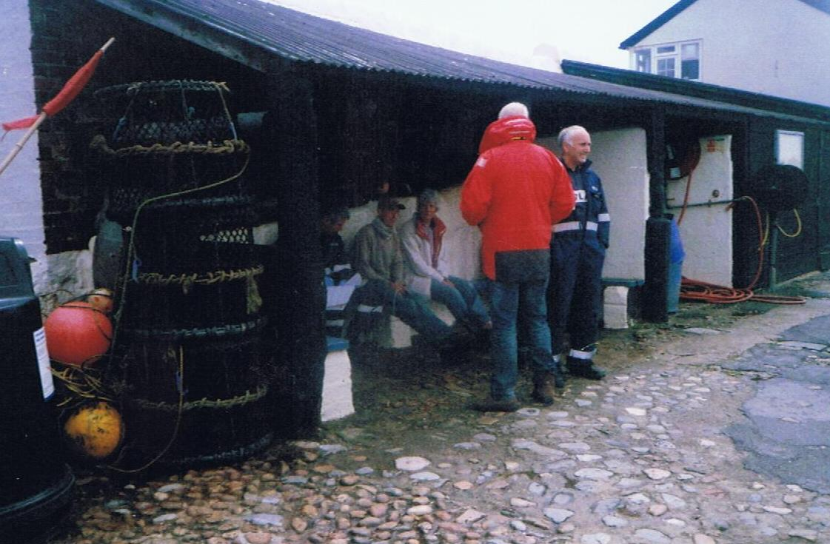

Photograph 7 Fishermen’s shelter at end of Cobb pier. A place of much discussion
5.14 HAZARD FIVE: fire
Fire is always a major hazard for ships or small boats and fire following from fuel leaks and gas explosions are all potential threats.
RISK 1a: From leakage on unattended vessels.
RISK 1b: From activities on vessels.
RISK 1c: In a tightly-packed harbour, fire or a gas explosion on one vessel can spread rapidly to others nearby.
RISK ASSESSMENT LEVEL:
L: Low
C: High
RESPONSE:
a) Call the fire brigade immediately. Alert other emergency services if there are likely to be injuries to people or any threat to bystanders on the quayside.
b) Remove other craft in the vicinity to create a fire break around the vessel on fire.
c) Ensure that all bystanders and people not involved in fighting the fire are kept well clear of the area and that access is clear for emergency services. The police, tasked with taking charge at the scene of any emergency connected to the land, should ensure this but harbour staff can assist, especially with first aid
d) If harbour staff are qualified and fighting the fire is within their capabilities they may tackle a blaze, once the alarm is raised.
COMMENTARY:
Lyme Regis is surrounded by public access quays, two-thirds of which vehicles can reach despite the awkward road access; it is therefore likely that emergency services will always be able reach a vessel on fire. Exercises are carried out with the local fire brigade to ensure that the response will be a well-drilled routine when needed.
5.15 HAZARD SIX: Moving craft on slipways and in boat parks
A large public slipway is provided at Lyme Regis over which the public may launch their boats. The Harbour Master operates a boatlift which is available to all boats (but mainly those too large for convenient trailering) which require moving from parks or slipway to and from the moorings. At low water the boatlift, hauled by a tractor, moves boats about the bed of the harbour to put them on or off moorings.
RISK 1a: Collision or other accidental contact between a boat on the move and other objects.
RISK 1b: Injury to persons caught unawares or otherwise getting entangled with a boat on the move
RISK 1c: Although the bed of the harbour is firm sand gravel over which it travels frequently, there is always the possibility of the boatlift getting stuck or of tilting dangerously on the untreated harbour bed. Only one incident of this nature has been recorded.
RISK 1d Boats being put into the water from trailers with the jockey wheel down on the trailer, come off the vehicle towing hook crossing the hump at the top of the slipway with consequent danger of running away down the slipway.
RISK ASSESSMENT LEVEL:
L: Low
C: Medium/high
RESPONSE:
a) Care is taken when manoeuvring with boats to ensure that all other boats, vehicles, and people in the vicinity are warned of the movement.
b) On the bed of the harbour, the soft spots and danger areas are known and avoided.
c) ensure jockey wheels are up until the trailer is down by the water’s edge.
COMMENTARY:
Movement of boats is a frequent occurrence at Lyme Regis and the risks are well-known to the operators. These activities mainly occur in areas open to the public, and the main danger comes from the less aware members of the public being taken by surprise.

5.16 HAZARD SEVEN: The Harbour beach area and swimming
The North pier of Lyme Regis harbour was originally a detached mole. Over time a large sandbank has built up at the inner (Northern) end of the harbour which connects the North Pier to the rest of the harbour and to the beach on the East side. This beach is very popular with the public for sunbathing and leisure activities. The whole area looks deceptively safe to the uninitiated and hence a great temptation. A wall has been built to deter this but the problem remains.
RISK 1a: This beach frequently tempts people to go swimming in the harbour despite warnings not to. With boats frequently on the move under power in the same area the risk to swimmers from propellers is considerable.
RISK ASSESSMENT LEVEL:
L: Low/Medium
C: High
RESPONSE:
a) Constant vigilance is exercised by the harbour staff to warn people off swimming in the harbour. Patrols are mounted through the summer season.
COMMENTARY:
While the wish of people on the harbour beach to swim is understandable, power-driven boats and swimmers are not a good mixture. Every means available to inform people of the risk and to discourage them from going swimming has to be deployed. These include warning signs and harbour staff telling all swimmers to get out of the water and go somewhere safer.
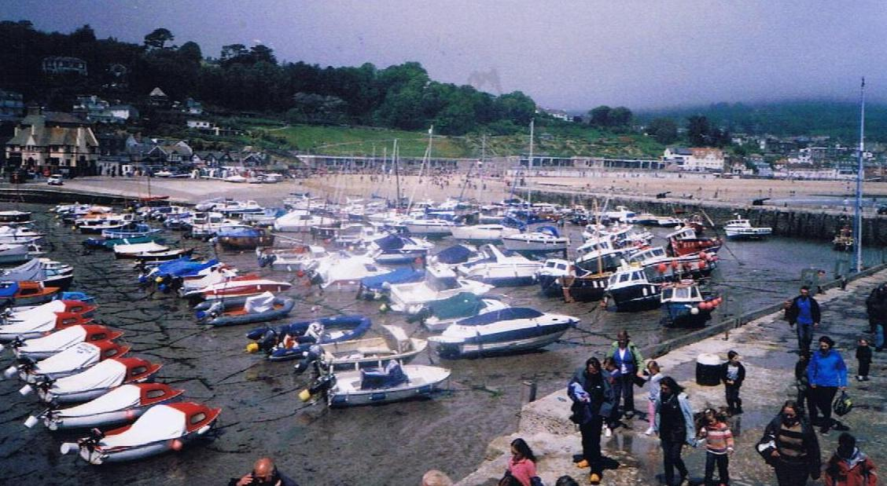

Photograph 8 View across the harbour with sandbank visible in centre

5.17 HAZARD EIGHT: loading and unloading goods
There are no cranes or shore-based aids to handling goods on and off ships at either harbour. In consequence boat owners extemporise. Some fishing boats can use their own gear; others climb up and down ladders one-handed, hanging their loads from their other hand. At high tide loads can be passed straight across between boat and quay. Permission has now been granted to erect a crane near the Cobb end, mainly for the benefit of the fishermen.
RISK 1a: Is of people slipping or losing their grip while on a ladder one-handed, and falling, either between boat and quay or into their boat. Both carry serious danger of injury.
RISK 1b: Is of loss or damage to goods when being manhandled across the gap between boat and quay.
RISK 1c: Is of loss or damage from using handling equipment which may not be certified or adequate for the load being handled.
RISK ASSESSMENT LEVEL:
L: Low
C: Low/medium
RESPONSE:
a) Vigilance is required to warn boat owners and operators of the dangers inherent in climbing ladders one-handed.
b) Lifting equipment should be tested and certificated for the use it is put to.
c) General care should be taken in handling goods between boat and quay, especially when swell is running into the harbour.
COMMENTARY:
The casual everyday handling of loads between boats and quayside goes on continuously, and largely without problem. But because of this familiarity, dangerous practices can creep in which lead to accidents. All harbour users should be educated and reminded of the risks they take.
5.18 HAZARD NINE: Passengers embarking and disembarking
Passengers are largely unfamiliar with boats and the sea. This can lead them to being hesitant in passing between the land and a boat. This has become particularly significant since cruise liners starting calling. They disembark their passengers at the pier end from their own boats and not all are particularly agile.
RISK 1a: Is of a passenger falling and injuring themselves.
RISK 1b: Is of a passenger falling between boat and quay and being trapped or crushed.
RISK 1c: Is of passengers drowning following a fall into the harbour.
RISK ASSESSMENT LEVEL:
L: Low/Medium
C: Medium/High
RESPONSE:
a) Close supervision by trip boat crew of all passengers stepping between quayside steps and their boat.
b) Harbour staff should monitor the swell condition in the harbour, and intervene to stop boats operating if it is felt necessary.
5.19 HAZARD TEN: Persons falling from Piers
As with all functioning harbours the pier edges are unfenced and cannot practically be fitted with security fencing. The Cobb in particular is a long pier which gets very busy in high season. This carries with it the inherent danger of people, either unfamiliar or too familiar with the pier, slipping or stepping over the edge. The one case of the person in a mobility wheelchair has already been noted.
RISK 1a: When there is water in the harbour, the risk is of people falling in and drowning.
RISK 1b: When the harbour is dry, the risk is of people injuring or even killing themselves by falling the full height from the quay edge to the harbour bottom, which in places is rocky and in all cases is at least firm.
RISK ASSESSMENT LEVEL
L: Low
C: Medium/high
RESPONSE:
a) Prompt response to falls is essential. People falling into the water may be injured as well, and hence unable to help themselves so they must be recovered quickly if they are to survive.
b) Call appropriate emergency services according to the place and seriousness of the accident.
c) Warn people of the danger.

EMERGENCY RESPONSE PLAN

Assigned Areas of Responsibility

All vessels in the harbour approaches
H M Coastguard is the co-ordinating authority for any incident in these areas, and will call in other services as necessary.

Craft in the harbour
The Harbour Master has a primary authority for dealing with incidents to vessels on the move farther into the harbour, calling in other services as necessary.

All craft alongside in the harbour
Craft alongside a berth come under general shore emergency provisions, which means that the police have the controlling responsibility, in co-operation with the Harbour Master as appropriate.

SOSREP
The Secretary of State has general superintendence throughout the United Kingdom of all matters relating to wreck. He is entitled to appoint a special representative (SOSREP) to exercise those powers on his behalf, or to appoint a Receiver of Wreck. The Secretary of State may appoint a representative to take control of any incident, whether within a port or not, and Harbour Masters are required to co-operate in dealing with the incident.
SOSREP has a particular brief to prevent or control pollution and is most likely to take charge when pollution may be involved, but his derogated powers are not limited to this area. The primacy of SOSREP is to be acknowledged in all marine emergency situations.
Action:
For emergency assistance the RCC and CHA should be contacted.

THE PLAN

General
The emergency responses of Lyme Regis are under the overall command of their Harbour Master, reporting to the SHA duty holder.
The port only has the capacity to deal with minor incidents from its own resources. An incident at port level would require additional expertise and resources. Whilst a major incident is not envisaged, this would call for significant resources and expertise from external services.
Should an incident occur requiring further resources the Harbour Master will receive support and approval from the Head of Environment and Wellbeing.
A full scale emergency would be initiated by the emergency services and would activate Dorset Council’s Emergency Plan.

Pollution
Lyme Regis is exempt from the need to have a full Oil Spill Response Plan, but carries small stocks of pollution control equipment. This is located in the stores building and harbour staff are fully familiar with its use.

Tug and Salvage Equipment Availability
There are no tugs at Lyme Regis. The Harbour Master’s RIB is a powerful craft capable of being used for basic tug duties such as moving vessels around in the harbour. For incidents outside the harbour, it is probable that the larger fishing boats could give first aid assistance to smaller boats and these should be looked to in the first instance. The nearest large tugs are at Portland, 25 miles away and available to move on about half an hour’s notice in the daytime, 4 hours’ notice at night. Their draft limitations would preclude their use in the harbour or its approaches.
There is some limited salvage capacity at Portland, which could be mobilised reasonably rapidly. At Lyme Regis the usual way of dealing with the small craft which use it is by the boat lifter which operates across the harbour bed at low water. Any craft which sank would be lifted ashore at the next low water and dealt with from there.

HM Coastguard
The area Marine Rescue Sub Centre (MRSC) is at Lee on the Solent. The sector manager is based at Lyme Regis; Lyme Regis has an auxiliary Coastguard Station which holds access equipment and shore support gear.
Solent Coastguard can be contacted by:
VHF channel 16 or 70 (DSC) or tel. 999

R N L I
There is an R N L I station at Lyme Regis with an Atlantic 75 lifeboat. To obtain lifeboat assistance, contact Solent Coastguard in the first instance.

Vessels Aground
As only small craft use the harbour which is tidal, vessels aground do not constitute a significant problem. Any vessel capable of using the port, if it could not be towed off, would be removed at low water by crane or boatlift.
There can be a problem in the entrance to Lyme Regis Harbour if a larger boat moors by the steps. It can become grounded at low water preventing smaller boats still afloat from operating at or using the steps.

Wrecks
For emergency assistance the MRSC should be contacted immediately by 999. The SHA duty officer should be advised of the problem, the action being taken and any action required of the SHA.
Lyme Regis Fire Brigade will attend any vessel fire within the ports.
Action:
a) If alongside within the harbour, call Fire Brigade Tel. 999
b) If on the move, Call Solent Coastguard VHF Channel 16 or 70(DSC)
Notify:
Position
Whether able to reach an access point and if so which one.
ETA at access point
Scale of problem
Number of persons on board
Type of fire
Type of vessel
Type and nature of assistance required

Persons in Difficulties in the Water
a) Outside the harbour mouth:
Action
Call Solent Coastguard VHF Channel 16 or 70 (DSC)
Notify:
Vessel name
Inbound/outbound
State of tide
Speed of current
Location
Number of persons in the water
Whether local assistance available
Solent Coastguard will decide appropriate response and if necessary will call the RNLI or other appropriate service.
b) Inside the harbour mouth:
When an incident is observed or the Harbour staff are informed, the Harbour Master or his assistant will ensure that the Coastguard is informed, take charge and co-ordinate the rescue until such time as the emergency services are established on site.
If time is of the essence and it is safe to do so, harbour staff may attempt to assist the person in the water and rescue them or move them to a safe location.

REPORTING, ASSESSMENT AND AUDIT

Overview

External Reporting
The port authority is required to report to the appropriate external authority whenever a major incident, an environmental hazard, or a sub-standard vessel is within their port limits.

Internal Reporting Chain
The internal reporting chain within Dorset Council is short and effective:
The Harbour Master reports to the Environment and Wellbeing Manager. He in turn reports to the SHA Duty Holder (normally via the Environment Overview & Scrutiny Committee but direct if necessary). Staff concerned with harbour operations will report to the Harbour Master.

Continuous Assessment
a) The Principal Engineer together with the Harbour Master keep the plans, policies and procedures under continuous review to ensure that they continue to provide best practice to nationally agreed standards.
b) At twelve-monthly intervals the process of continuous assessment is to be monitored in accordance with Section 2.2. This will normally be done in the early spring before the main boating season commences.
c) Whenever change appears necessary under the continuous assessment process, affected parties are to be consulted before the change is implemented.

Investigation and Reporting
The reporting of events within the port has to be made to appropriate authorities whenever called for. Any physical checks or action required should be put in hand. Any event also triggers an immediate review of those aspects of plans, policies and procedures which are affected by it, to seek out and amend any deficiencies shown up by the event.
i) Incident reports by skippers to the Harbour Master to include:
Near miss between boats
Touching bottom when on the move
Berthing and unberthing or mooring problems
ii) Status reports by Harbour Master or staff to Environment and Wellbeing Manager each Monday morning, to include:
Incidents
Moorings
Aids to Navigation
Safety Equipment around the Harbour.
Access landings and ladders
iii) Report to Environment and Wellbeing Manager at monthly meeting of Tier 4 managers. The Environment and Wellbeing Manager reports to the Duty Holder, as and when events require, and always in accordance with Section 2.2.
Material condition of the harbour
Reporting of incidents
Operational difficulties
Dangerous acts
Port statistics

The audit trail

Introduction
The Port Marine Safety Code requires every port to carry out a full-scale review and audit of its entire safety system at intervals no greater than three years.
It is preferred that the review is undertaken by an outside body.

Twelve-Monthly Review
The Harbour Master should monitor, that is make a more structured examination of the port’s workings, every twelve months at which time all employees should be formally asked if they have any inputs to make, and the duty holder consulted.
The following should be addressed:
i) Are the port’s legal framework, bylaws and directions appropriate, and if not what amendments should be recommended to the Competent Harbour Authority?
ii) Is the port being operated in accordance with the requirements of the Port Marine Safety Code and the Guide to Good Practice?
iii) Are the policies, plans and procedures described herein being carried out? If not, why not? Does this plan require amendment or is there some deficiency in the managing and operating of the port?
iv) Have all statutory requirements, surveys and local regulations been complied with?
v) Have there been any incidents in the previous year which call for review of the Safety Management System?
vi) Have the elements of the operations plan all functioned to the level expected of them? If not, what remedial action is being taken?
vii) Have emergency systems been tested, and is progress towards or the results of the annual major exercise being developed?
viii) Have appropriate notices been given?
ix) Have any consultees affected by any activity in the last period been consulted, and with what results?
x) Are there any upcoming changes, events, or problems to be considered, and if so what action is being taken to prepare for them?
xi) What training has been carried out in the period, and what is planned both for the next period and the next year?
xii) Any other relevant considerations.
This monitoring should be recorded and signed for by the Environment and Wellbeing Manager and Harbour Master and delivered to the Duty Holder by including it in the annual report with a recommendation that the Duty Holder (The Harbour Committee) accepts the report. Once satisfied with its contents The Harbour Committee as Duty Holder formally approves the report making comments as appropriate.

External Reporting
a) Sub-standard vessels
Every port has had a duty to report any sub-standard vessel or crew which visits the port in accordance with Notice MSN1775. In January 2011 MIN 380 advised that a new regime is being brought into force to comply with latest international requirements, and a new MSN will be issued. In the meantime ports should continue to be advised by the former MSN 1775 which has now been withdrawn.
The procedure to be followed is as laid down in that notice. That is the Harbour Master will note and if necessary refuse permission for any sub-standard vessel to enter or to move, advising the MCA. All advices should be in writing, signed and dated.

Reporting Of Incidents, Accidents or Disasters
Other than emergency services, the external authority to whom ship damages, stranding’s, sinking’s, fires and other events concerning ships or crews should be reported to is the MCA.

Internal Investigation and Reporting
All significant unplanned events within the port must be investigated by the Harbour Master as soon as possible after the event.
All staff within the port must be trained to record the event, making contemporaneous notes.
Whenever possible photographs should be taken. Photographs taken at the time are sometimes a most powerful way of dealing with questions after the event.
The objective always is to ensure that there is sufficient evidence to be able to draw conclusions about the event. Such contemporaneous records can be very important also in providing information for insurance interests, and in providing the employer or authority with the information to deal with any claims which may arise.
Where it is not practicable to make contemporaneous notes, those involved should be debriefed by the Harbour Master as soon after the event as is possible. In all cases the record must be agreed and signed by all parties involved.

Reporting
Reports on all significant unplanned events within the port should be addressed to the chairman of the CHA by way of:
a) The Environment and Wellbeing Manager
In addition:
b) Copies go to the Chief Executive, CHA
c) The Insurance Manager
d) Dorset Council’s Emergency Planning Officer

Public Scrutiny
The plan showing conformity with the Port Marine Safety Code has to be available for public scrutiny. A copy of the latest plan should be lodged in a public place such as a library or available at the Harbour Master’s Office. As an alternative, posting the latest plan on the Council’s website satisfies the Code’s requirement that the plan should be publicly available.
Port Marine Safety Code

END

THIS IS THE LAST PAGE OF THE
LYME REGIS MARINE OPERATIONS PLAN

