OPERATIONS PLAN AND SAFETY MANAGEMENT SYSTEM

THE HARBOUR OF BRIDPORT
(West Bay)

November 2022

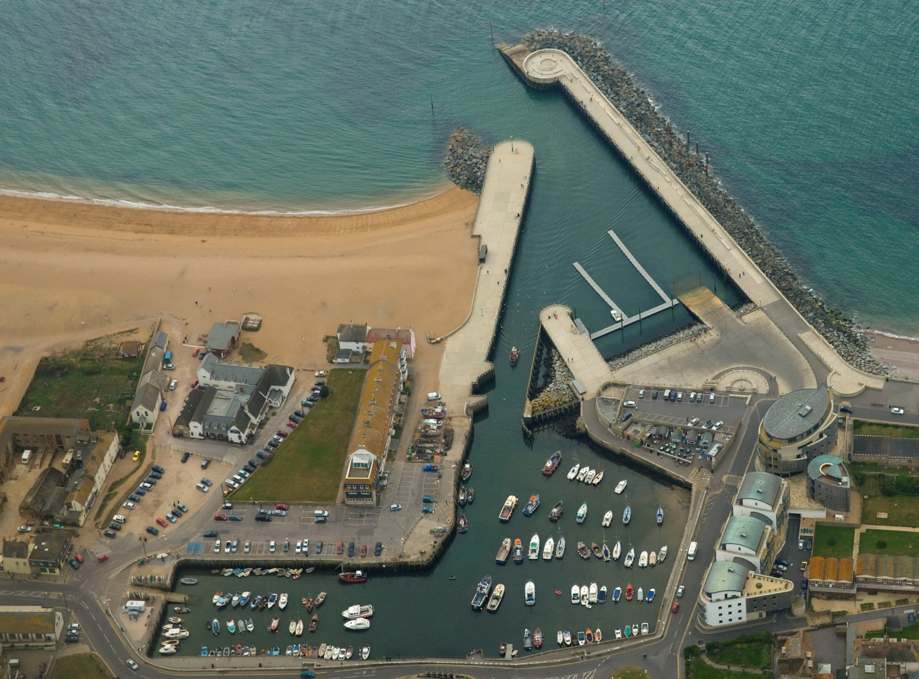

Update | Reviewed by | Date
Original Report | CF Spencer & Co Ltd | February 2002
Update | West Dorset District Council | 2005
Update | West Dorset District Council | 2006
Update, Audit and Assessment | Maritime Resolve ltd. | September 2012
Update | R Noakes - West Dorset District Council  James Radcliffe (Harbour Master) | 2015
Update | R Noakes - West Dorset District Council  James Radcliffe (Harbour Master) | 2017
Update | R Noakes - West Dorset District Council  James Radcliffe (Harbour Master) | 2018
Review and update | R Noakes – Dorset Council  James Radcliffe (Harbour Master) | August 2019
Audit and Assessment | William Heaps – Marico Marine | June 2022
Update | J Radcliffe and K Buchan – Dorset Council | November 2022

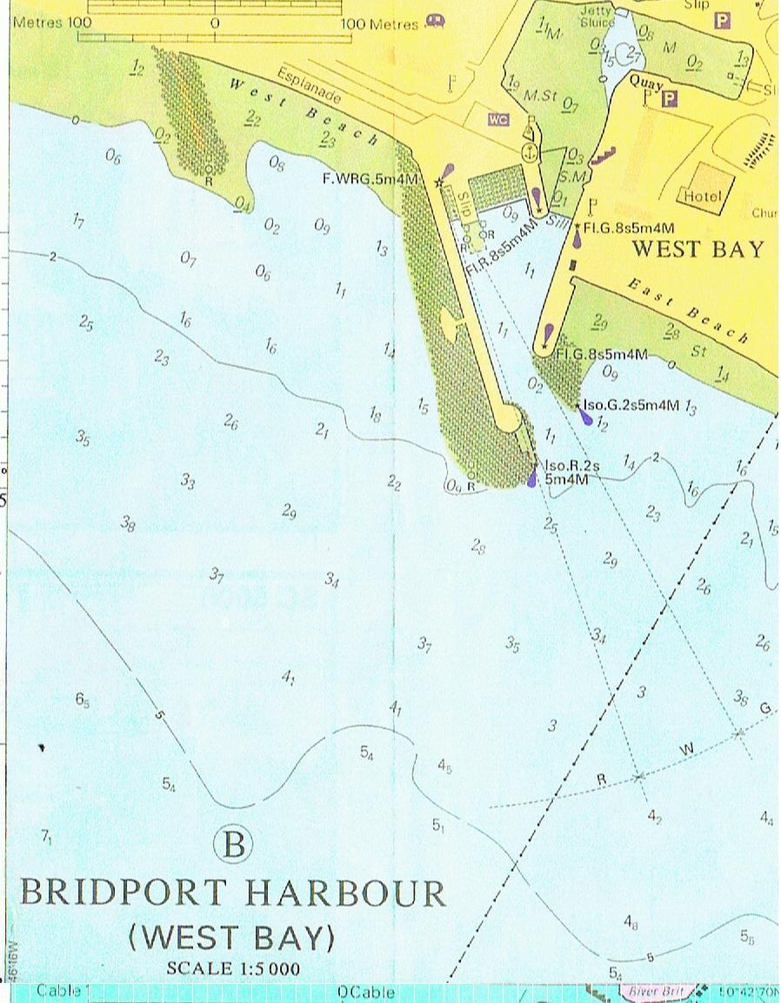

CONTENTS
- THE PORT OF BRIDPORT (WEST BAY) 8

  - Harbour Limits 8

  - Tidal Range 9
1.3 Anchorages 9
1.4 Ship Parameters 10
1.5 Port Users 10
1.6 Designated Nature Conservancy Sites 10
2. LEGAL STRUCTURE; PROFESSIONAL STAFF; POLICY 10
2.1 Statutory Authority 10
2.2 Legal Duties and Powers 10
2.3 Enabling Legislation 10
2.4 By-laws 11
2.5 Harbour Rules 11
2.6 Directions 11
2.7 Harbour Revision Orders 11
2.8 Accountability 11
2.9 The Duty Holder 11
2.10 The Designated Person 11
2.11 Professional Staff 11
2.12 Policy 11
2.13 Statement of Policy 11
2.14 General Management Policy 12
2.15 Environment 12
2.16 Marine Safety Policy 12
2.17 Systems and Standards 13
2.18 Training 13
2.19 Consultation 13
3. KEY PERFORMANCE INDICATORS 13
3.1 Operation 13
3.2 Conservancy 14
3.3 Hydrography 14
3.4 Emergencies 14
3.5 Tide Watch 14
3.6 Consultation 14
3.7 Audits and Continuous Assessment 14
4. SAFETY MANAGEMENT SYSTEM 14
4.1 General 14
4.2 Introduction to the Council System 16
4.2.1 Summary 16
4.2.2 Hazard 16
4.2.3 Risk 16
4.2.4 Risk Assessment 16
4.3 Responsibilities 17
4.4 Categories of Risk Diagram 19
4.5 Generic Risk Assessments 20
4.6 Review of Risk Assessments 21
4.7 Bridport Harbour Safety Management System Hazard and Risk Management 21
4.8 Safety 23
4.9 Lines of Authority 23
4.10 Structure of the Safety Management System 24
4.11 Free Standing Plans Now Adopted into the System 25
4.12 Integration of the Elements 25
5. OPERATIONS PLAN 26
5.1 Overview of Port Movement Control 26
5.2 Communications 26
5.3 Collison Regulations 26
5.4 Speed Limits 26
5.5 Vessel Traffic Service (VTS) 26
5.6 Pilotage 26
5.7 Passage Plan 27
5.8 Training and Qualifications 27
5.9 Berth Operators and Private Users 27
5.9.1 Freight 27
5.9.2 Passenger Ships 27
5.9.3 Hazardous Goods 27
5.9.4 Leisure Users 27
5.10 Moorings 27
5.11 Fishing Vessels 28
5.12 Charter Boats 28
5.13 Dangerous Vessels 28
5.14 Wrecks 29
5.15 Conservancy 29
5.16 Standards and Inspection of Aids to Navigation 30
5.17 Dredging, Hydrography and Admiralty Charts 30
5.18 Meteorology 30
5.19 Tugs 31
5.20 Works Licensing 31
5.21 Event Management 31
6. EMERGENCY RESPONSE PLAN 32
6.1 Assigned Areas of Responsibility 32
6.1.1 All Vessels in the Harbour Approaches 32
6.1.2 Craft in the Harbour 32
6.1.3 All Craft Alongside in the Harbour 33
6.2 SOSREP 33
6.3 The Plan 33
6.3.1 General 33
6.3.2 Pollution 34
6.3.3 Tug and Salvage Equipment Availability 34
6.3.4 HM Coastguard 34
6.3.5 RNLI 34
6.3.6 Vessels Aground 34
6.3.7 Wrecks 34
6.3.8 Fire 35
6.3.9 Persons in Difficulties in the Water 35
7. REPORTING, ASSESSMENT AND AUDIT 35
7.1 Overview 35
7.1.1 External Reporting 36
7.1.2 Internal Reporting Chain 36
7.2 Continuous Assessment 36
7.3 Investigation and Reporting 36
7.4 The Audit Trail 37
7.4.1 Introduction 37
7.4.2 Twelve Monthly Review 37
7.5 External Reporting 38
7.6 Internal Investigation and Reporting 38
7.7 Reporting 39
7.8 Public Scrutiny 39

Photograph 1 – Bridport West Bay new Outer Basin and Harbour Mouth 8
Photograph 2 – View Looking Inwards Across Outer Basin to Inner Harbour 25
Photograph 3 – Looking Across Outer Basin with South-Easterly Seas Rolling
In 31
Photograph 4 – Bridport New Slipway with Sea Breaking In

Figure 1 – Bridport Harbour Limits 9
Figure 2 – Summary of Risk Assessment Process 17
Figure 3 – Categories of Risk Diagram 19
Figure 4 – Table of Risk Level 19
Figure 5 – Table of Risk Level and Acceptability 20
Figure 6 – Plan, Do, Check and Act 21
Figure 7 – Harbour Governance Structure 24
Figure 8 – Staff Structure at Bridport Harbour 24
Figure 9 – General Emergency Response Flowchart 33

- THE PORT OF BRIDPORT (WEST BAY)
The Port of Bridport lies in 50° 42.6’N, 002° 45.8’ W, in the North-East part of Lyme Bay. It is a single basin formed at the mouth of the River Brit, but the river is now held behind a dam and sluice gates at the inner side of the harbour, and there is no navigational connection between the two. The new harbour at West Bay consists of a single tidal basin which largely dries out at low water. Originally the port was in Bridport town, some two miles upriver, but silting and a difficult navigation made a new outer harbour necessary, and the basin of West Bay was created in Victorian times.
In 2005 Bridport harbour mouth was extensively rebuilt to make the entrance safer; an outer basin and entrance were created set at an angle to lessen the weather effect in the entrance. Except for strong South-Easterlies, this new construction has been effective.

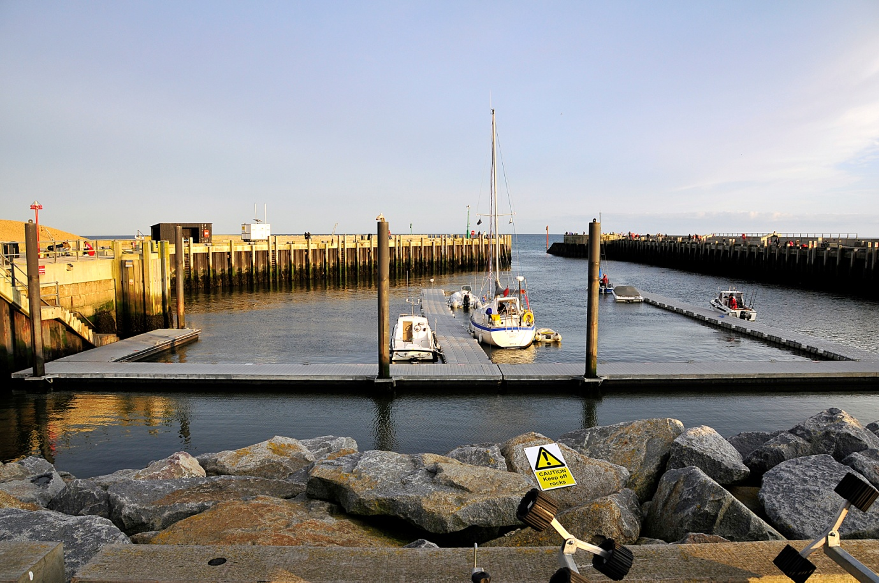
Photograph 1 Bridport West Bay new outer basin and harbour mouth

  - Harbour Limits
The Bridport harbour limits consist of a semi-circle of 1,000 feet (304.88m) radius, centred on the pier ends (Figure 1).

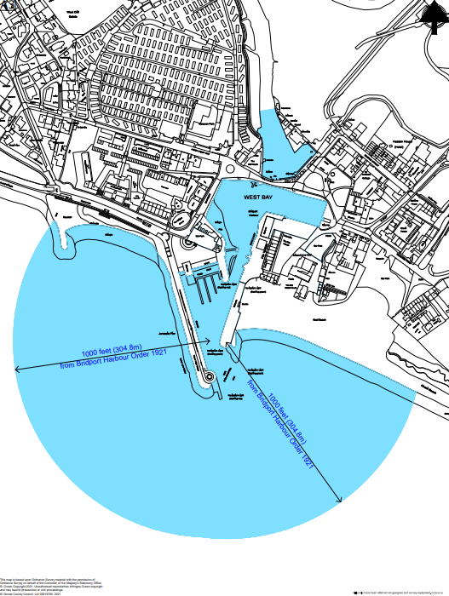

Figure 1 Bridport Harbour Limits
  - Tidal Range
The tidal range at Bridport is a maximum of 4.6m on highest spring tides, and a minimum of 0.9m on slackest neap tides. The harbour very rarely dries out at low water and all movements in the port are on the tides.
1.3 Anchorages
There are no designated anchorages at Bridport.
At Bridport ships can anchor about 740m South of the pier ends, or farther out beyond the 10m contour. The area is completely open from South-East through South to West and offers no shelter to weather from those sectors. A choppy sea can get up very rapidly in Lyme Bay when the wind rises from an exposed quarter.
1.4 Ship Parameters
There are no set size limits for craft in Bridport, and in times past coasters used the port. Nowadays only small fishing boats and yachts enter, and a length of 21m, beam 3.75m, and draft 2.4m, would be considered the maximum practicable in the harbour.
1.5 Port Users
Bridport Harbour is used by a fleet of small fishing boats, some charter boats, and leisure craft of various types. There is no commercial traffic (other than fishing boats) nor any expectation that there will be. The inner basin is completely filled with small craft moorings.
1.6 Designated Nature Conservancy Sites
Bridport harbour limits are located inside the boundary of the Lyme Bay and Torbay Marine Special Area of Conservation. The river Brit from the dam at West Bay up to Bridport town is an SSSI. The only craft operated on the river above the dam are a small fleet of day hire rowing boats which are licensed annually by the Bridport harbour master. The entire coast from Sidmouth to West Bay/Bridport is an SSSI and much of it also a Special Area of Conservation (SAC). The Jurassic Coast World Heritage Site extends from Orcombe Point in Exmouth to Old Harry Rocks near Swanage, its boundaries broadly defined as between mean low water mark to the top of the cliffs or back of the beach.
- LEGAL STRUCTURE; PROFESSIONAL STAFF; POLICY
2.1 Statutory Authority
Dorset Council (DC) is the Statutory Harbour Authority (SHA) and Competent Harbour Authority (CHA) for Bridport. It is answerable to its electorate via the councillors both in direct approaches and at the ballot box.
2.2 Legal Duties and Powers
Bridport has a very long history. It is an open port, into which any user has a right to navigate on payment of harbour dues. There is a duty to operate it safely for the benefit of all such users. The berths and wharves are under the control of the Harbour Master.
2.3 Enabling Legislation
Bridport operates under an Order of 1921, when the port’s ownership was transferred from Trust Commissioners to Bridport Corporation; the title subsequently passed to West Dorset District Council (WDDC) in 1974. WDDC changed to Dorset Council in 2019.

2.4 By-laws
Bridport has a set of by-laws drawn up in 1945 and believed still to be in force. In addition a general set of Dorset Council by-laws, mainly concerned with conduct on roads and in public places, has force in the harbour area.
2.5 Harbour Rules
Mooring holders are required to comply with additional rules and a Harbour Policy document. This is made public via Bridport Harbour, West Bay in Dorset
2.6 Directions
There are no directions extant.
2.7 Harbour Revision Orders
There are no Harbour Revision Orders in force, but one has been submitted and Dorset Council are currently awaiting approval.
2.8 Accountability
Dorset Council as the SHA and CHA is accountable for its duties and powers. Its discharge of this responsibility is measured against nationally agreed standards as laid down in the Port Marine Safety Code and amplified in the Code’s accompanying Guide to Good Practice.
2.9 The Duty Holder
Under the terms of the Port Marine Safety Code, the Portfolio Holder for Highways, Travel and the Environment is the Duty Holder.
2.10 The Designated Person
The Designated Person for Bridport, Lyme Regis and Weymouth Harbour is James Hannon (Associate Maritime Consultant, ABPmer).
2.11 Professional Staff
Dorset Council employs a Harbour Master an Assistant Harbour Master a permanent 20 hour Harbour Assistant and a 40 hour seasonal Harbour Assistant at Bridport with day-to-day operational responsibility for the Harbour.
2.12 Policy
As required by the Port Marine Safety Code, Dorset Council publishes its policies, plans and periodic reports, setting out how they comply with those standards and these are found below.
2.13 Statement of Policy
Dorset Council as the Statutory Harbour Authority (SHA) is committed to undertaking and regulating marine operations so as to safeguard the harbours, their users, the public and the environment.
The Authority aims to run a safe, efficient, cost-effective, sustainable harbour operation for the benefit of all users and the wider community.
The Authority aims to meet the national requirements in the Port Marine Safety Code, and fulfil its legal responsibilities whilst endeavouring to meet the changing needs of harbour users.
2.14 General Management Policy
As required by the “Code”, Dorset Council publishes its policies, plans and periodic reports, setting out how they comply with the Code’s standards, and these are found below.
A document ‘Harbour Policy’ is also published on Bridport Harbour, West Bay in Dorset which regulates much of the activity in the harbour.
Dorset Council as the Statutory Harbour Authority (SHA) is committed to undertaking and regulating marine operations to safeguard the harbours, their users, the public and the environment.
The authority aims to run a safe, efficient, cost-effective, sustainable harbour operation for the benefit of all users and the wider community.
The authority aims to meet the national requirements in the Port Marine Safety Code and fulfil its legal responsibilities whilst endeavouring to meet the changing needs of harbour users.
The Council will support the commercial, fishing, and recreational activities in the harbours through the provision of appropriate services of good value.
The policy of the Council is to:
- Manage the assets of the Authority safely, economically and efficiently.
- Train the operational staff and ensure they are properly trained in emergency and contingency procedures.
- Regulate traffic within the harbour limits to ensure safe and efficient movements.
2.15 Environment
The SHA and its authorised officers are aware of their environmental commitments. Although there are no designated conservation areas within the harbour limits, the local environment is considered important and the impact on it will be a material consideration if any changes to the existing situation are proposed.
2.16 Marine Safety Policy
The Council and its staff will ensure marine safety by:
- Providing a safe environment for navigation through aids to navigation and conservancy.
- Regulating activities within the port as required by statute.
- Training and educating staff, users and the public in safety awareness.
- Ensure as far as reasonably practicable the safety at work of its employees and other people who may be affected by its activities.
- Application of the Port Marine Safety Code and its supporting Guide to Good Practice through this Marine Operations Plan.

2.17 Systems and Standards
The plans established in this document have been developed on the basis of a formal risk analysis, and a Safety Management System evolved in response to that risk analysis. It is based on the “As Low As Reasonably Practicable” (ALARP) principle, which aims to reduce risk levels to the lowest practical level.
2.18 Training
The harbour has a full training policy. All Councillors as part of the Full Council and specifically Harbours Committee members and Duty Holder are expected to undertake appropriate lectures to give them an understanding of their duties and responsibilities, particularly regarding the Port Marine Safety Code and its application. Training is conducted at least annually and as necessary to match the election cycle of the Council.
Professional staff officers are properly qualified for their duties, with the current Harbour Master having completed all mandatory training. Any new marine staff will be required to train and obtain appropriate qualifications for their role in the harbour if they do not have correct qualifications already.
A programme of updating knowledge and renewing qualifications when required, is pursued and records kept of all staff qualifications and training.
2.19 Consultation
Representatives of all regular user groups were consulted in the creation of this Code. Provision is made under the continuous assessment procedure for any change which affects a consultee to be consulted before or at the time of any such change.
In the course of preparation of the PMSC Plan for Bridport, the following were consulted:
- Harbour Staff.
- Fishermans’ Association.
- West Bay Small Boat Owners’ Association (no longer active).
The Bridport Harbour Consultative Group which is comprised of representatives of the main harbour user groups are kept informed of changes to harbour operations and consulted where appropriate.
- KEY PERFORMANCE INDICATORS
Dorset Council considers the following key responsibilities apply to its ports, all of which conform to the best practice requirements of the Port Marine Safety Code and its appending Guide to Good Practice.
  - Operation
To operate the port and regulate vessel movements to provide a 100% incident-free service.

  - Conservancy
To maintain and operate all navigation marks and lights to at least IALA standards.
A sand and shingle bar can build up between the piers at Bridport Harbour under certain weather conditions. Should this occur it is either scoured away at the earliest opportunity or, should this fail, it is dug out.
  - Hydrography
The Harbours will be surveyed as and when necessary, by professional surveyors. Where appropriate the results will be notified to the Hydrographer of the Navy.
  - Emergencies
To ensure ongoing training is maintained in all emergency procedures within the port.
  - Tide Watch
Although rare, the harbour staff at Bridport attend when a tide watch is called by the Environment Agency and operate the hatches if necessary. They also check for problems in the harbour and assist in protecting adjacent property from flooding at any one of three levels. The need for tide watch has receded since the building of the new outer harbour but is still a theoretical possibility.
  - Consultation
Both commercial and leisure user representatives meet regularly as part of the Bridport Harbour Consultative Group normally in April and October (pre and post season), but the Harbour Master is available on a daily basis to discuss with boat owners and operators any areas of concern.
  - Audits and Continuous Assessment
Ensure continuous assessment is carried out with periodic internal reviews of all port functions.
Carry out a full formal audit at not more than three year intervals, of all port functions and report the results publicly.
- SAFETY MANAGEMENT SYSTEM
4.1 General
The purpose of this document is to specify the content of the Marine Safety Management System (MSMS) which shall describe the means by which the Statutory Harbour Authority (Dorset Council), and the Portfolio Holder for Highways, Travel and Environment as Duty Holder for the safe and effective management of marine and environmental affairs will carry out this responsibility within its jurisdiction at Lyme Regis Harbour.

The Port Marine Safety Code (PMSC) refers to some of the existing legal duties and powers that affect Harbour authorities in relation to marine safety, but it does not in itself create any new legal duties for Harbour authorities. There are however several additional measures which, although not mandatory under legislation, are key to its successful implementation.

In order to comply with the PMSC therefore, Harbour Authorities must:

- Be aware of their existing powers and duties.
- Appoint someone as an independent “Designated Person” with direct access to the Duty Holder
- Develop an effective marine safety management system, which employs formal risk assessment techniques.
- Employ people who are competent and qualified for the positions they hold.
- Publish a comprehensive safety plan, along with a regular assessment showing the authority’s performance against the plan.

The Marine Safety Management System should be in place to ensure that all risks are controlled – the more severe ones must either be eliminated or kept ‘‘as low as reasonably practicable (ALARP)”.

Bridport Harbour also uses the safety and risk management system of its owner, Dorset Council. It defines risk management as “the culture, processes and structures that are directed towards effective management of potential opportunities and threats to the organisation achieving its objectives”.

At its highest level the Council’s risk management strategy requires that the wider implications of the port’s operations at a political, financial and social level should be built into the risk management system.

West Bay is particularly busy throughout the summer months, with homes, bars, and restaurants, and shops in close proximity to the harbour. This means that the effects of its Safety Management System spread beyond the marine consequences of the PMSC’s definition of risk. Where specific hazards would have their own specific responses under the PMSC, with steps identified to eliminate or control them to ALARP levels, the broader vision of the Council’s approach also requires those much wider factors to be considered.

The Council and harbour staff have a wide range of stakeholders to whom they answer: the Council as the Statutory Harbour Authority and Duty Holder, the people of the area to whom the Harbour is an important aspect of their lives, its many direct stakeholders and users whose livelihoods may depend on it, the many visitors and not least the professional staff whose job it is to run the Harbour.

The Council’s approach to risk also requires that the financial consequences of the harbour's operations are not put at risk while the PMSC requires that the harbour is properly maintained to be a safe harbour for all users. As an open harbour, available to all craft able to fit into it against the payment of proper dues, there is a direct legal requirement that it is fit to be used. Such maintenance costs money and the balance between finance and physical safety is constantly under review through the risk management system.
4.2 Introduction to the Council System
4.2.1 Summary
A statutory requirement, and central to the management and control of risks from hazards, is the use of risk assessments. A risk assessment is a paperwork exercise to review any work situation that allows relevant risks to be identified, recorded, communicated, and reduced where it is reasonable to do so. A duty exists for Dorset Council to reduce risk to the lowest reasonably practicable level. This duty extends to ensuring that risk assessments are suitable and sufficient and identify measures to be taken that ensure work tasks are safely undertaken.
4.2.2 Hazard
Something with a potential to cause harm. A situation that could occur which has the potential for human injury, damage to property, damage to the environment, or economic loss.
4.2.3 Risk
An estimation of the likelihood and potential consequences of a defined hazard, risk expresses the likelihood that the harm from a particular hazard is realised. Risk therefore reflects both the likelihood that harm will occur and its severity.
4.2.4 Risk Assessment
Risk assessments should normally be completed using a template which can be sourced from the Council’s forms register. Workplace areas with higher risk, i.e., harbours, may determine that a different and more comprehensive risk assessment template is more appropriate. The same principles of the risk assessment process will still apply.

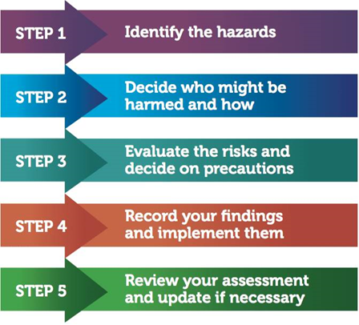
Figure 2: Summary of Risk Assessment Process

4.3 Responsibilities
Service managers should ensure that risk assessments are completed for all staff under their control. Line managers should ensure that members of staff who undertake risk assessments are competent to do so, have a good level of subject knowledge and are aware of the limitations of their expertise. Staff should be advised to seek further advice if needed.

Members of staff charged with undertaking risk assessments (Assessors) should be suitably trained in order that risk assessments undertaken are both suitable and sufficient and have the benefit of reducing risk. Risk assessment training can be sourced through the Health, Safety and Welfare Officers.

To help further understand the method for assessing risk Dorset Council have adopted a matrix that allocates numbers to judgements made. The higher the severity and likelihood, the higher the number between one and four is selected. Once numbers replace judgements these can be multiplied together to give a risk rating.

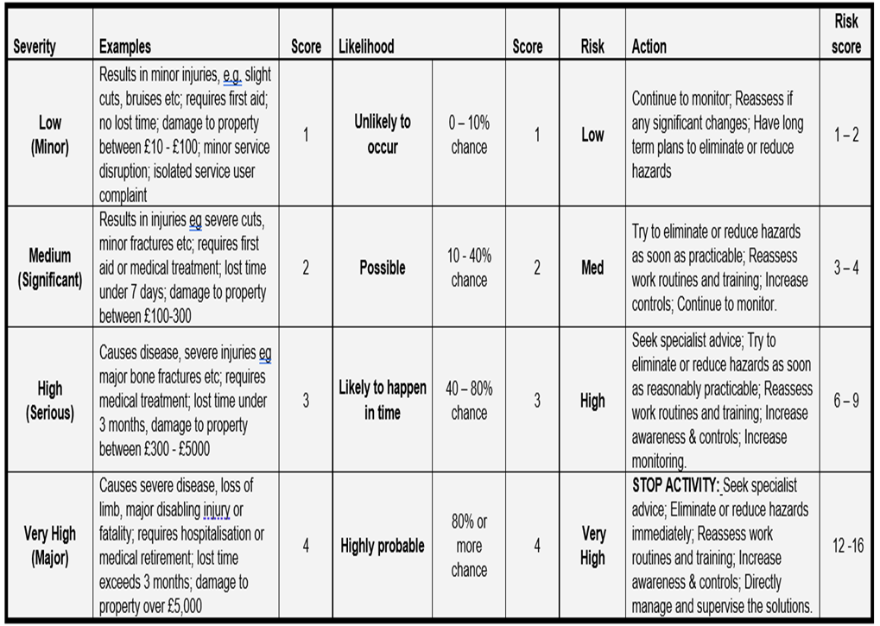
Five steps to risk assessment:
1. Look for the hazard.
2. Decide who might be harmed and how.
3. Evaluate the risk and decide if existing controls are adequate or more should be done.
4. Record the findings.
5. Review periodically or when significant changes occur.

Refer to:
Dorset Council Risk Assessment Policy & Procedure
Health and Safety Executive subject guidance
Manufacturers’ Handbooks and web sites
Training Manuals
Codes of Practice
Existing workforce knowledge
Accident reports and other appropriate sources of information

4.4 Categories of Risk Diagram
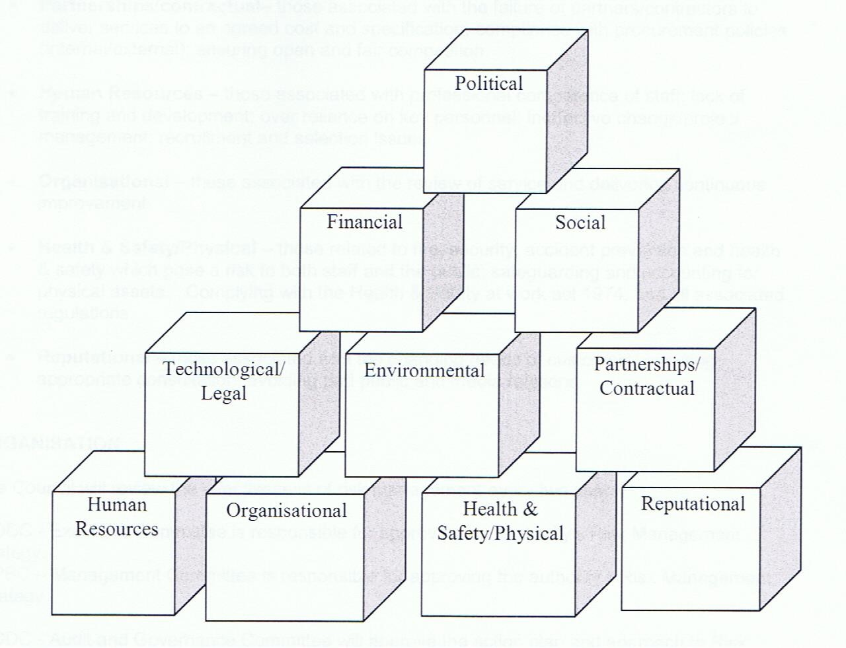

Figure 3: Categories of risk diagram

There is some overlap between this set of considerations, and those of the PMSC but also extra elements which between them provide for a comprehensive view of risk management.

The Council risk registers lay out the matrices of risk level and acceptability. The non-marine risks of the port are assigned levels from within these matrices, and the Safety Management System demonstrates how they are managed. The specific marine hazards that come within the definitions of the PMSC, by being assigned values from within the Council matrices, are incorporated in one cascading system. All the hazards and risks identified are catalogued in The Risk Register Document. Two of the comprehensive risk management system matrix systems are shown:
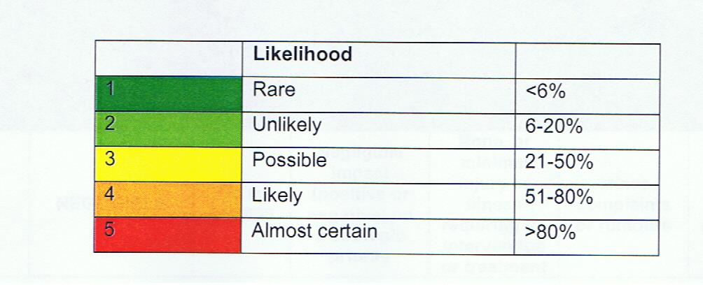
Figure 4: Table of risk level

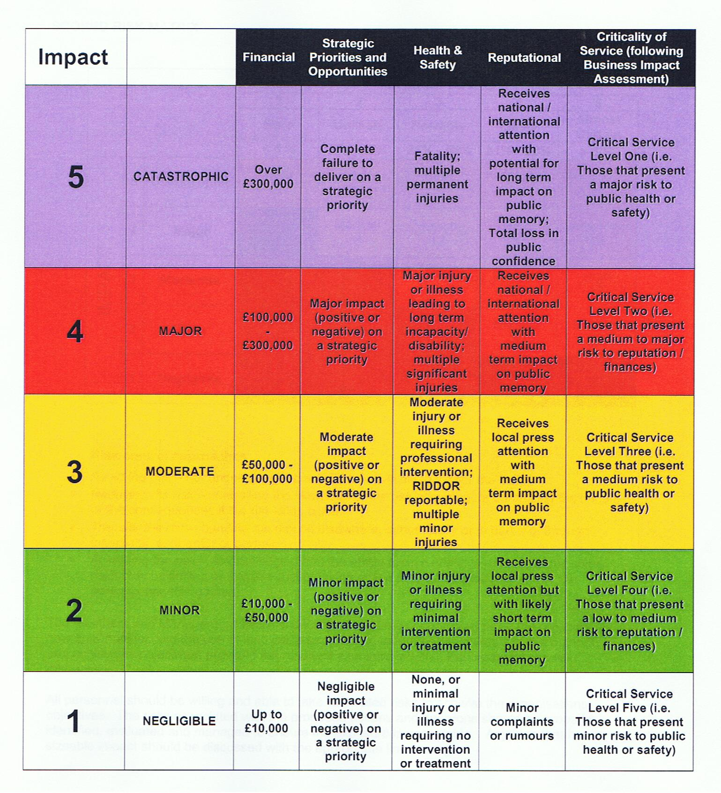
Figure 5: Table of risk level & acceptability

4.5 Generic Risk Assessments
Several generic risk assessments against common hazards were provided by Dorset Council as a framework for services to use and adapt. These will be adopted by the Harbour to avoid unnecessary effort. The following are available to date:

1. Management of Health and Safety at Work | 2. Risk Assessment
3. Accidents, Incidents and Disease | 4. Asbestos
5. Confined Spaces | 6. Construction (Design and Management) regulations 2008
7. Contractors | 8. COSHH
9. Display Screen Equipment | 10. Fire Risk Management
11. Health and Safety Training | 12. Home Working
13. Lifting Operations and Lifting Equipment | 14. Management of Workplace Stress
15. Manual Handling | 16. New and Expectant Mothers
17. Noise at Work | 18. PAT Testing
19. PPE | 20. Provision and Use of Work Equipment
21. Road Safety | 22. Safety Signs
23. Slips and Trips | 24. Travelling Officers and Lone Workers
25. Working at Heights | 26. Young People

4.6 Review of Risk Assessments
The Harbour risk registers and assessments will be reviewed:

- whenever a new activity is started.
- at least on a minimum annual basis in accordance with Dorset Council policy.
- whenever an accident or incident occurs.
- when significant changes occur to work practices that may impact on health, safety and welfare.

The review will normally be led by the Harbour Master and will consult Harbour Staff, Dorset Council experts and external assistance including the Harbour Consultative Group. The risk assessment methodology is demonstrated under the plan, do, act and check philosophy as shown below.

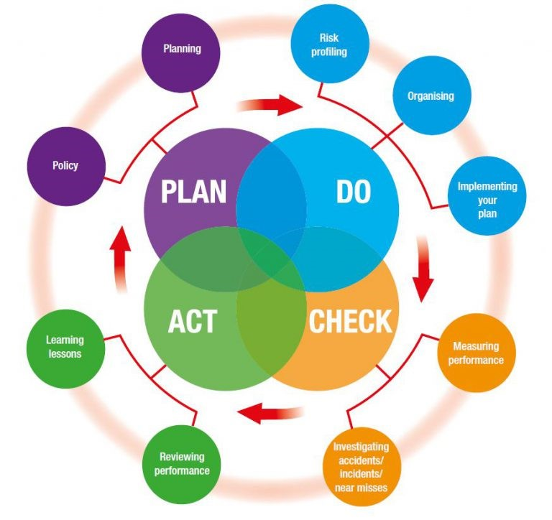
Figure 6: Plan, Do, Check and Act

4.7 Bridport Harbour Safety Management System Hazard and Risk Management
Since the reconstruction of its entrance in 2005, Bridport has shed its reputation as the second most dangerous port in the UK. Nevertheless, its entrance remains a demanding one if the weather comes at all strongly from East of South, with substantial seas rolling in and dissipating against the defences round the outer harbour. The inner harbour basin is now relatively calm, with a firm bottom which allows of craft taking the bottom on each low tide with a high degree of safety. The old practise of ‘sluicing’, which could pose a hazard, has largely ceased although as it remains a possibility it remains an identified hazard. The building of a new slipway as part of the outer harbour construction has removed the hazards associated with use of the slipway in the inner basin. It remains in place but is no longer in regular use. Overall, Bridport/West Bay is a safer place than it used to be.
With the exception of extreme weather conditions, those hazards that exist are not major and more generally relate to the port’s popularity as a small boat centre.
The Port Marine Safety Code requires that a port’s powers, policies, plans, and procedures must be based on a formal assessment of hazards and risks. Harbour authorities must have formal safety management systems.
To comply with this, the hazards within the port of Bridport have been identified, the risks associated with each evaluated, and the element of the Safety Management System which applies to that risk described.
List of Hazards Identified:
1) Entrance channel.
2) Swell within harbour.
3) Tide across the entrance.
4) Vessels refuelling.
5) Fire.
6) Slipway operations.
7) Harbour bed scouring using sluicing.
Hazards and associated risks are outlined in detail in an accompanying risk register to enable frequent review and update.
Other hazards considered possible, but not meriting full examination
Tidal surges or cuts: The normal tidal rise at Bridport stays below the quay edge and protective barrier walls are in place for exceptional tides which rise over the lowest parts of the quay edge. The flooding which can occur on the highest spring tides associated with bad weather is a hazard when it occurs. When it may occur harbour staff are alerted by the Environment Agency (EA) and they attend a tide watch with the EA. Should the EA consider there is a risk of significant flooding they will instigate a Major Incident Plan (MIP). Dorset Council will then follow its Civil Emergency Plan.
Collision between small craft in the harbour: Both ports are busy, especially in the summer, with yachts, fishing boats, and charter boats all manoeuvring in the same area, but speeds are low and there is no record of anything other than minor bumps ever having occurred. Should there be a more major collision, the port is well organised to deal with it.
4.8 Safety
Safety is not a separate discipline, isolated from the workings and day-to-day life of a port. The full and proper application of safety measures allows an incident-free and safe working environment in which ships go about their business without hazard.
The objective of the Port Marine Safety Code is to ensure that every element in a port’s operation follows the same unitary system of safe working practices, working within which is automatic and embedded in the way everyday activities are carried out. To this end it prescribes lines of authority, actions to be taken, and the way in which the port’s activities are to be carried out to achieve that level of safety.
Within the Marine Operations Plan for Bridport, safety has been integrated at all levels.
4.9 Lines of Authority
Bridport Harbour has a simple and effective line of authority. The Harbours sit under Place Services in Dorset Council. Dorset Council is the Statutory Harbours Authority. The Portfolio Holder for Highways, Travel and the Environment is the Duty Holder. Daily operations are performed by harbour staff with the Harbour Master reporting to the Head of Environment and Wellbeing who in turn reports to the Corporate Director for Place Services. Dorset Council’s Harbours Committee play and advisory role. The Harbour Master reports formally to the Committee and Duty Holder at quarterly committee meetings but has access to the Duty Holder at any time.
The Harbour Master, supported by the Harbour staff, has day to day responsibility for managing the safe operation of navigation and other marine activities in the area of jurisdiction. He/She is authorised to act on behalf of the Duty Holder in the course of his/her duties to meet the requirements of the Port Marine Safety Code, Business Plan and Harbour Budget. The Harbour Master is authorised to exercise all powers granted by statute to his position.
In the absence of the Harbour Master, the Assistant HM will manage day to day operations.
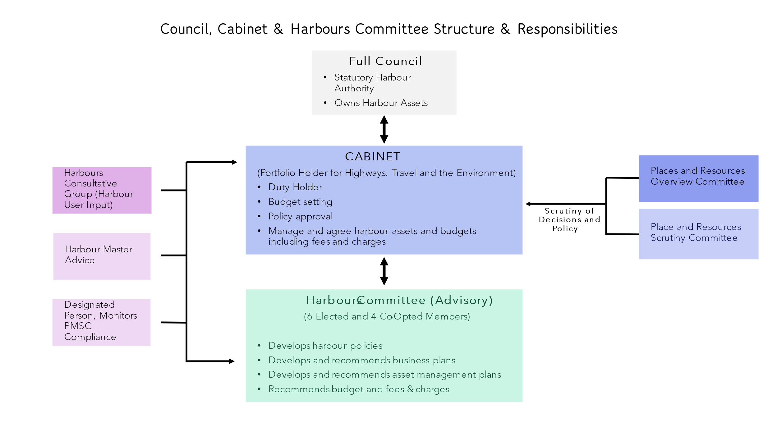
Figure 7: Harbour Governance Structure
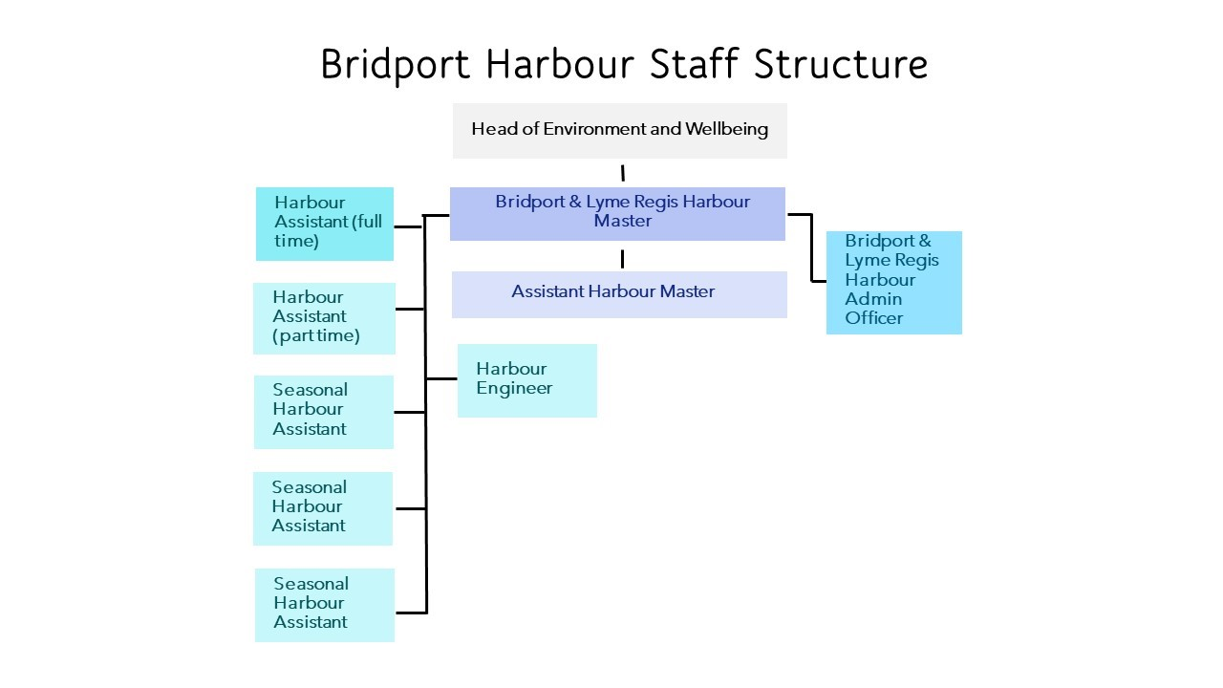
Figure 8: Staff structure at Bridport Harbour

4.10 Structure of the Safety Management System
The Safety Management System provides a framework for the operation of the port and is in three parts:
Port Procedures: The port procedures lay down the practical day-to-day working practices of the port as contained in the Marine Operations Plan.
Risk Assessment: The Formal Risk Assessment identifies and grades the risks likely to occur within the port of Bridport/West Bay.
Responses: to risks identified in the formal risk assessment are contained within the Marine Operations Plan.
4.11 Free Standing Plans Now Adopted into the System
There are four plans adopted into the Safety Management System:
- Dorset Council Civil Emergencies Plan
The District Emergency Plan lays out the systems to be used for any emergency in the district. Should any incident in the harbour area have consequences reaching beyond its confines, it is the regional plan which will be brought to bear.

- Coastal Oil Pollution Response Plan
The port is below the size limit for the requirement to have an individual oil pollution response plan, but is party to the Coastal Region plan which is being re-written after experience of an exercise.

- Environment Agency Major Incident Plan for West Bay
This plan deals with flooding of West Bay from tidal or fluvial events. It is to be incorporated into the Civil Emergencies Plan.

- Waste Management Plans
A Dorset Council waste management plan approved by MCA is in force. This is made public via Waste Management - Bridport Harbour, West Bay

4.12 Integration of the Elements
Only a limited number of people are involved in running the port; there is a clearly defined senior officer, the Harbour Master, in charge of all practical marine matters. His reporting line is also short and clear, and hence the scope for uncertainty or confusion is minimised.
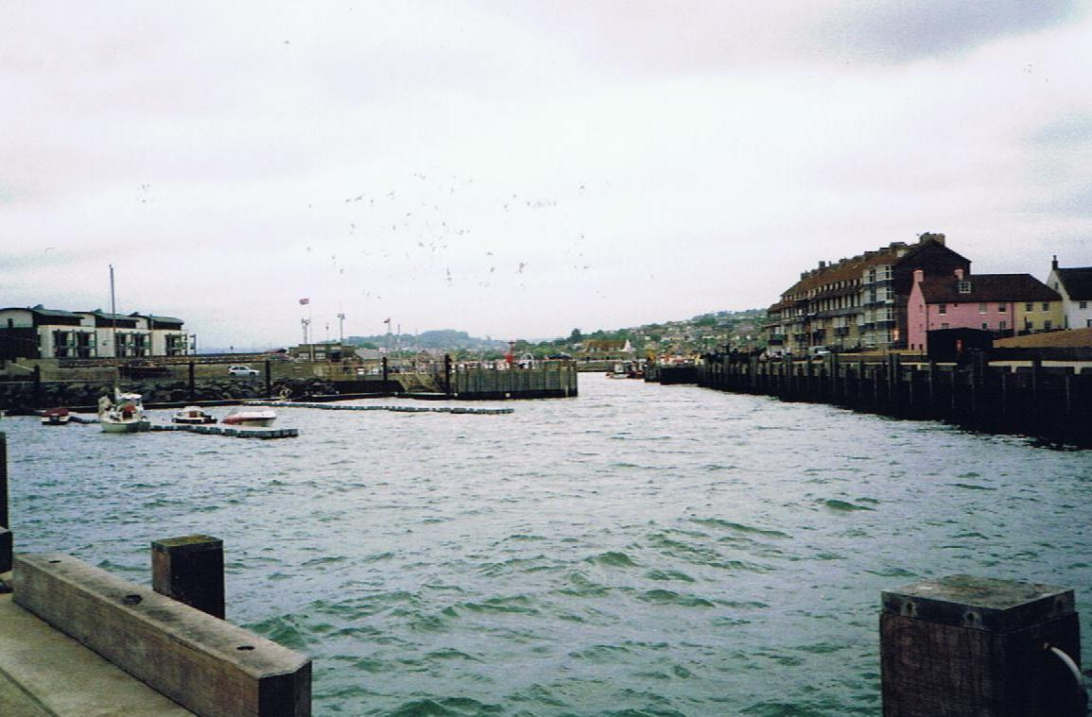
Photograph 2 View looking inwards across outer basin to inner harbour
- OPERATIONS PLAN
5.1 Overview of Port Movement Control
For the most part, traffic movement in and out of Bridport is left to the skippers of craft on the move. At Bridport most are regular users familiar with the entrance and have no difficulty avoiding each other. There is an understanding that craft outside the entrance channel must give way to craft which are in it and allow them to clear before entering.
The Harbour Master has reserve rights to direct vessel movements and determine priorities when the need arises. Given the port’s excellent safety record there seems little point in changing the simple direct intervention methods which have been so effective.
When required, navigation control is carried out by the Harbour Masters or their assistants by direct intervention from the quayside, or by VHF radio. There are no formal navigation control centres. Bridport is equipped with a fast patrol boat, used both within the harbours and to police the beaches and inshore waters around their harbours.
Two documents, the “Rules for Harbour Users at Bridport and Lyme Regis”, and “Harbour policy” control the behaviour of port users at both ports. Both documents are updated in November each year and are published on Harbour Policies - Bridport Harbour, West Bay
5.2 Communications
When the Harbour Master is in attendance he listens and works on VHF Channel 16 and 11 at Bridport.
5.3 Collison Regulations
Vessel movements are carried out in conformity with he provisions of the International Regulations to Prevent Collision at Sea, 1972, as amended.
5.4 Speed Limits
At Bridport, a speed limit of bare steerage way is in force within the harbour. Outside the harbour entrance, an 8 knot limit is in force.
In the harbour limits and over an extensive coastal strip from Eype by way of West Bay to the mouth of the River Bride, a speed limit of 8 knots is enforced. This is intended to keep vessel speeds to the legal minimum when within 200 metres of any beach.
5.5 Vessel Traffic Service (VTS)
There is no VTS service at Bridport
5.6 Pilotage
Officially, pilotage is compulsory at Bridport. But there has not been an act of pilotage since 1985, and no expectation that any vessel will call at Bridport requiring a pilot. Accordingly, the Dorset Council as owners and managers of the port is considering seeking to relinquish their pilotage duties and the CHA status of the port once legislation permits. A harbour Revision Order may be used for this.
No pilots are authorised; should any vessel request the services of a pilot, guidance could be given and visiting yachts have on occasion been led inwards by the harbour boat.
5.7 Passage Plan
As there is no pilotage service, there is no requirement for a formal passage plan system to be in place. The Harbour Master will give advice, by radio if appropriate, to visiting craft on request.
5.8 Training and Qualifications
The SHA requires its Harbour Master to have had suitable harbour experience. Each year one aspect of the port’s emergency response regime should be subject to a full-scale response exercise and the other aspects be subject to refresher training with all relevant equipment surveyed and checked as necessary.
The Council operates a staff appraisal scheme where the training, further qualifications, or revalidation, needs of all staff are assessed. A training plan for the following year is then drawn up and implemented as resources allow.
5.9 Berth Operators and Private users
5.9.1 Freight
There is no freight traffic in Bridport. The last commercial cargo vessel called in 1986 and there is no foreseeable prospect of freight returning.
5.9.2 Passenger Ships
There are no passenger vessel calls at Bridport. Day trip charter boats take ‘round the bay’ excursion traffic.
5.9.3 Hazardous Goods
Apart from small quantities of fuel for the port’s boats, no hazardous goods are handled at either port.
5.9.4 Leisure Users
There is an active boating community based at Bridport, with 132 private moorings let for leisure purposes. They are made up of 28 commercial fishing boats, 83 yachts and the rest small day fishing boats. Many of these are small privately-owned motor boats for non-commercial fishing. In 2011 173 other small fishing boats landed at Bridport.
5.10 Moorings
Bridport West Bay harbour is extensively filled with moorings. These are strictly controlled by the Harbour Masters on behalf of Dorset Council, which has the sole authority to authorise moorings. Most moorings are in trots, laid to ground chains across the harbour. Both the ground chains and risers are provided by the Council, boat owners providing their own rope attachments. Ground chains and risers are inspected annually by the Harbour Masters and their staff, it being the Council’s responsibility to maintain these. The upper parts of moorings are the responsibility of the berth holder. Ground chains have to be renewed every 3 to 4 years.
There is a waiting list – in 2022 about 33 people - for moorings with a waiting time in the order of 3 years. Moorings are allocated annually giving priority to existing mooring holders, then to Dorset Council ratepayers on the waiting list. Controls are in place to ensure fair allocation.
A large new launching slip was built into the outer basin as part of the 2005 harbour mouth reconstruction. With its coming into service the older slipway in the inner basin was taken out of use but is still in place.
Two documents, the “Rules for Harbour Users at Bridport and Lyme Regis”, and “Harbour Policy” deal in detail with harbour use, moorings use and allocation, and general behaviour in the harbour area. This is published on Harbour Policies - Bridport Harbour, West Bay
5.11 Fishing Vessels
A total of 14 professionally-run fishing boats are based at Bridport. These are inshore trawlers or pot boats, with some swapping between functions to suit the seasons. There is one larger vessel and plans for a second one. The rest are of modest size and only operate on a day-trip basis. Catches are landed at Bridport, direct to transport, but there is no fish market as such. The catches are bought and transported by Samways, an old-established fish trading business which has its origins in Bridport but is now much more widely spread. When the tide is out it is not unusual for fishing boats to land their catches on the seaward wall.
5.12 Charter Boats
There are 14 trip charter boats operating from Bridport. These provide trips round the bay, boat rides, sea angling, and diving activities. All are MCA licensed under the latest Codes of Practice.
5.13 Dangerous Vessels
The Dangerous Vessels Act of 1985 defines a dangerous vessel as:
- One which poses a grave and imminent danger to the safety of any person or property within the port;
- One which may, by sinking or foundering in the harbour, prevent or seriously prejudice the use of the harbour by other vessels.
Harbour Masters have powers to deal with such vessels and may give orders to the owner, master, or any other person, including a salvor, who may be in charge of such a vessel.
If it is practicable to do so, the first step should be to require the person in charge of a dangerous vessel to make it safe immediately. If they are unwilling or unable to do so, the Harbour Master may take steps himself to make it safe or to remove it, having a usual lien over the ship for the cost of doing so.
In many cases a vessel will become dangerous very rapidly and leave no time for considered action. The port’s emergency plan must be initiated, according to the problem the dangerous ship has. The Harbour Master’s duty is to protect life and property, while ensuring that his port can continue to operate.
A port is not bound to accept from sea a dangerous vessel which requests entry, but the 1985 Act states that in making a decision the Harbour Master must have regard to the safety of any person or vessel, whether in or outside the harbour.
5.14 Wrecks
There are no wrecks close to Bridport.
Port authorities have a common law duty to ensure that their harbours are safe for navigation and, equally, to warn ships using the harbour of any hazards within its port. Wrecks are an important consideration within this duty.
In the first instance, any body having control of a wreck has a duty to remove it and Harbour Masters are entitled to demand that they remove it forthwith.
That said, Harbour Masters have powers to deal with any wrecked vessel which is, or is likely to become, an obstruction or danger to navigation or to lifeboats within his port or its approaches.
These powers are:
- to take possession of, and raise, remove, or destroy the whole or any part of the vessel and any other property to which the power extends;
- to light or buoy the vessel or part of the vessel and such other property until it is raised, removed or destroyed.
Beyond this, the Secretary of State has general superintendence throughout the United Kingdom of all matters relating to wreck. He is entitled to appoint a special representative (SOSREP) to exercise those powers on his behalf, or to appoint a Receiver of Wreck. The Secretary of State may appoint a representative to take control of any incident, whether within a port or not, and Harbour Masters are required to co-operate in dealing with the incident.
SOSREP has a particular brief to prevent or control pollution and is most likely to take charge when pollution may be involved, but his derogated powers are not limited solely to this area.
5.15 Conservancy
At Bridport, the permanent navigation marks are the two lights on perches marking the seaward end of the groins from the pier ends. Both are isophase 2 second lights, a red to port and a green to starboard. There is also a Flashing green 8 seconds light on the East pier end. A fixed sector light shows a white light marking the entrance channel, with red to port and green to starboard over the piers. The inner harbour entrance has a flashing red 8 seconds light on the inner pier end, and a flashing green 8 seconds opposite. These lights mark the sill protecting the inner harbour erected as part of the outer basin development. Other unlit perches have baskets on top as day marks. All permanent navigation lights at Bridport are powered by mains electricity without emergency back-up, but as both ports are very largely daylight only operations, this is not considered to be a major problem.
Trinity House is the General Lighthouse Authority for England and Wales responsible for annual inspections of Local aids to Navigation and biennial Audits. All placing, removing and repositioning of AtoNs is to be via TH consent and defects and casualties are to be reported to TH as they occur via the online reporting system accessed on the TH website.
5.16 Standards and Inspection of Aids to Navigation
The Dorset Council aims for a minimum of IALA standards, which for its ports is category three. Dorset Council is a local light authority and its aids have been subject to an annual inspection by Trinity House, the last being in June 2021. Reports are made under the Panar system.
5.17 Dredging, Hydrography and Admiralty Charts
Bridport is prone to shoaling both in its entrance channel, and within the harbour. In the entrance channel, sand is swept around the pier ends from the adjoining beaches and tends to build up along the East outer pile encroaching into the entrance channel. Annually it is necessary to dredge this build up using cutter suction dredgers and pump the material to the west cliff beach.
Bridport can still practice the ancient art of sluicing. There are a series of sluice gates separating the harbour from the River Brit. The sluice gates are owned by the Environment Agency who are responsible for the river but operated by the harbour staff according to laid down procedures. It was last done seriously in 2005.The sluice water moves with considerable force, so use of it is always advertised in advance to warn boats to keep out of its way. Normal practise is to restrict this to the winter months when there are much fewer boats in the harbour.
Bridport harbour is surveyed three times a year by a launch from the firm Shoreline Surveys. It examines the harbour and the sea bed out to the harbour limit 1,000 feet from the pier ends. The surveys are done in March, and pre-and post- dredging. Any major changes are notified by a Notice to Mariners with a copy to the Hydrographer of the Navy.
5.18 Meteorology
Bridport is seriously affected by the weather. Lyme Bay is open to the Atlantic from the South-West quadrant, and very large seas can buffet the area in strong gales. In addition, any wind from the south can very quickly kick up a short sea uncomfortable for small boats.
Bridport had what is considered to be the second most dangerous entrance in Britain for small craft. Heavy seas swept the entrance, with large swells running up the channel and into the harbour. On average the port was closed for 190 days a year due to bad weather. The building of the new outer harbour has made a major difference and days lost to weather are now under fifty a year. The construction of the new outer harbour and entrance in 2005 was primarily to alleviate the effect of bad weather on the port. The mouth of the harbour was re-oriented to a more south-easterly direction and enlarged. In the outer harbour wave absorbing defences were put in place and strategically located groins built to check the run of wave or swell into the harbour. This has been effective, and the inner basin is now rarely seriously disturbed by seas although the outer basin can be somewhat rough. The entrance is more available and apart from weather direct from South-south-east is much more readily navigable.
Movement is considered to be largely self-regulating: the boats only operate by day and if bad weather is expected imminently, or the entrance is difficult of exit, boats do not go out and hence the need to provide protective measures for craft struggling to make the entrance is minimised. The harbour master can and does provide weather warnings and advice when appropriate.
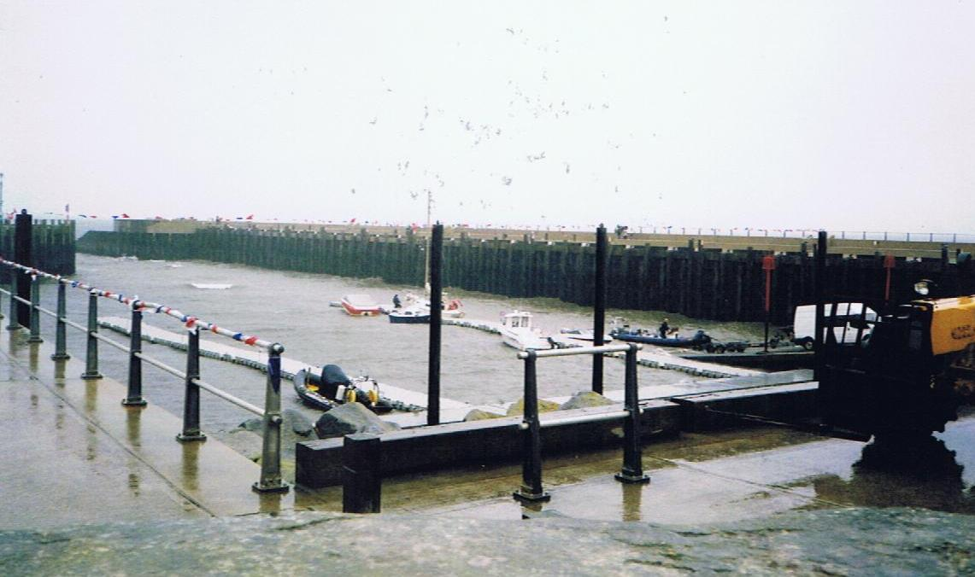
Photograph 3 Looking across outer basin with south-easterly seas rolling in
5.19 Tugs
There are no tugs available at Bridport, the nearest source being Portland or, for a smaller tug, Weymouth. Local fishing boats have, on occasion, given a tow to other craft in difficulties. See Emergency Plan.
5.20 Works Licensing
Major works are either carried out by direct labour of Dorset Council, or by contractors directly controlled by the Flood and Coastal Erosion Risk Management Team so the need for licensing is minimised. Works carried out are agreed with the Harbour Master and controlled by the Principal Engineer in consultation with Dorset Council officers. It is rare, other than dredging, for such works to affect navigation. Minor works are carried out by the harbour master himself, and/or his staff.
5.21 Event Management
Bridport hosts many events through the year, and an informal level of risk analysis, along with a high degree of organisation, has always gone into planning these events. Gig racing is proving popular.
The ‘Guide to Good Practice’ annexed to the Port Marine Safety Code requires risk analysis to be carried out fully by the organisers before any event is allowed to go ahead, and the results of the risk analysis must be given to the Harbour Master.
In 2009 a thorough review of the arrangements for holding events and for carrying out the concomitant risk assessments was carried out. It is up to the organisers of each event to carry out their risk assessment of their event. The Harbour Authority ‘notes’ each risk assessment presented by the organisers of events, and unless it chooses not to approve them they can go ahead. It is normal for events to be insured and it is felt that, providing the insurers are willing to accept and underwrite the event, this should be enough for the Harbour authority.
In turn the Harbour Master must be satisfied that the event meets the requirements of the Coastguard, the RNLI, and the shore-based emergency services. Where a national body represents the type of craft taking part in an event, any guidance or code provided by that body should be adhered to.
When submitting their risk analysis it goes to the Dorset Council Property Services team., and event organisers must also inform them of:
Names of event organisers and officials;
- List of participants;
- List of authorities consulted;
- Timetable and programme of events;
- Arrangements for controlling the event, including any special communications;
- Any navigational constraints being imposed such as restricted areas or partial port closures;
- Emergency arrangements;
- Media arrangements.
Any additional resources required from the Harbour Master, the Council or the emergency services will normally be at the expense of the event organiser.
- EMERGENCY RESPONSE PLAN
  - Assigned Areas of Responsibility
    - All Vessels in the harbour Approaches
H M Coastguard is the co-ordinating authority for any incident in these areas and will call in other services as necessary.
    - Craft in the Harbour
The Harbour Master has a primary authority for dealing with incidents to vessels on the move farther into the harbour, calling in other services as necessary.

    - All Craft Alongside in the Harbour
Craft alongside a berth come under general shore emergency provisions, which means that the police have the controlling responsibility, in co-operation with the Harbour Master as appropriate.
  - SOSREP
The Secretary of State has general superintendence throughout the United Kingdom of all matters relating to wreck. He/She is entitled to appoint a special representative (SOSREP) to exercise those powers on his behalf, or to appoint a Receiver of Wreck. The Secretary of State may appoint a representative to take control of any incident, whether within a port or not, and Harbour Masters are required to co-operate in dealing with the incident.
SOSREP has a particular brief to prevent or control pollution and is most likely to take charge when pollution may be involved, but his derogated powers are not limited to this area. The primacy of SOSREP is to be acknowledged in all marine emergency situations.
Action:
For emergency assistance the RCC and CHA should be contacted.
  - The Plan
6.3.1 General
The emergency responses of Bridport/West Bay are under the overall command of their Harbour Master, reporting to the SHA duty holder.
The port only has the capacity to deal with minor incidents from its own resources. An incident at port level would require additional expertise and resources. Whilst a major incident is not envisaged, this would call for significant resources and expertise from external services.
Should an incident occur requiring further resources the Harbour Master will receive support and approval from the Head of Environment and Wellbeing.
A full scale emergency would be initiated by the emergency services and would activate Dorset Council’s Emergency Plan.
Figure 9: General emergency response flowchart
6.3.2 Pollution
Bridport is exempt from the need to have a full Oil Spill Response Plan but carries small stocks of pollution control equipment. This is located in the stores buildings and harbour staff are fully familiar with its use.
6.3.3 Tug and Salvage Equipment Availability
There are no tugs at Bridport. The Harbour master’s RIB is a powerful vessel capable of towing small craft in and around the harbour. Outside the harbour, it is probable that the larger fishing boats could give first aid assistance to smaller boats, and these should be looked to in the first instance. The nearest large tugs are at Portland, 25 miles away and available to move on about half an hour’s notice in the daytime, 4 hours’ notice at night. Draft limitations preclude the use of large tugs in the harbour or its immediate approaches.
There is some limited salvage capacity at Portland, which could be mobilised reasonably rapidly. At Bridport the usual way of dealing with the small craft which use them is by crane, working from the shore. Any craft which sank would be lifted ashore at the next low water and dealt with from there.
6.3.4 HM Coastguard
The area National Maritime Operations Centre (NMOC) is at Lee on Solent. The senior Coastal Operations Officer (SCOO) is based at Winfrith, Wool; Bridport has an auxiliary Coastguard Station which holds access equipment and shore support gear.
Solent Coastguard can be contacted by:
VHF channel 16 or 70 (DSC) or tel. 999
6.3.5 RNLI
There is no RNLI station at Lyme Regis with an Atlantic 85 Lifeboat. To obtain lifeboat assistance, contact Solent Coastguard in the first instance.
6.3.6 Vessels Aground
As only small craft use Bridport which is tidal, vessels aground do not constitute a significant problem. Any vessel capable of using the ports, if it could not be towed off, would be removed at low water by crane.
6.3.7 Wrecks
For emergency assistance the NMOC should be contacted immediately by 999. The SHA duty officer should be advised of the problem, the action being taken, and any action required of the SHA.

6.3.8 Fire
Bridport Fire Brigade will attend any vessel fire within the ports.
Action:
a) If alongside within the harbour, call Fire Brigade Tel. 999
b) If on the move, Call Solent Coastguard VHF Channel 16 or 70(DSC)
Notify:
- Position
- Whether able to reach an access point and if so which one.
- ETA at access point
- Scale of problem
- Number of persons on board
- Type of fire
- Type of vessel
- Type and nature of assistance required
6.3.9 Persons in Difficulties in the Water
a) Outside the harbour mouth:
Action
- Call Solent Coastguard VHF Channel 16 or 70 (DSC)
Notify:
- Vessel name
- Inbound/outbound
- State of tide
- Speed of current
- Location
- Number of persons in the water
- Whether local assistance available
- Solent Coastguard will decide appropriate response and if necessary will call the RNLI or other appropriate service.
b) Inside the harbour mouth:
When an incident is observed or the Harbour staff are informed, the Harbour Master or his assistant will ensure that the Coastguard is informed, take charge and co-ordinate the rescue until such time as the emergency services are established on site.
If time is of the essence and it is safe to do so, harbour staff may attempt to assist the person in the water and rescue them or move them to a safe location.
- REPORTING, ASSESSMENT AND AUDIT

  - Overview

7.1.1 External Reporting
The port authority is required to report to the appropriate external authority whenever a major incident, an environmental hazard, or a sub-standard vessel is within their port limits.
7.1.2 Internal Reporting Chain
The internal reporting chain within Dorset Council is short and effective:
The Harbour Master reports to the Head of Environment and Wellbeing. He in turn reports to the SHA Duty Holder. Staff concerned with harbour operations will report to the Harbour Master.
  - Continuous Assessment
The Harbour Master keeps the plans, policies and procedures under continuous review to ensure that they continue to provide best practice to nationally agreed standards.
b) At twelve-monthly intervals the process of continuous assessment is to be monitored. This will normally be done in the early spring before the main boating season commences.
c) Whenever change appears necessary under the continuous assessment process, affected parties are to be consulted before the change is implemented
7.3 Investigation and Reporting
The reporting of events within the port has to be made to appropriate authorities whenever called for. Any physical checks or action required should be put in hand. Any event also triggers an immediate review of those aspects of plans, policies and procedures which are affected by it, to seek out and amend any deficiencies shown up by the event.
- Incident reports by skippers to the Harbour Master to include:
- Near miss between boats
- Touching bottom when on the move
- Berthing and unberthing or mooring problems

- Status reports by Harbour Master or staff to The Head of Environment and Wellbeing each week, to include:
- Incidents
- Moorings
- Aids to Navigation
- Safety Equipment around the Harbour
- Access landings and ladders

- The Head of Environment and Wellbeing reports to the Duty Holder, as and when events require.
- Material condition of the harbour
- Reporting of incidents
- Operational difficulties
- Dangerous acts
- Port statistics
7.4 The Audit Trail
7.4.1 Introduction
The Port Marine Safety Code requires every port to carry out a full-scale review and audit of its entire safety system at intervals no greater than three years.
It is preferred that the review is undertaken by an outside body.
7.4.2 Twelve Monthly Review
The Harbour Master should monitor, that is make a more structured examination of the port’s workings, every twelve months at which time all employees should be formally asked if they have any inputs to make, and the duty holder consulted.
The following should be addressed:
i) Are the port’s legal framework, bylaws and directions appropriate, and if not, what amendments should be recommended to the Competent Harbour Authority?
ii) Is the port being operated in accordance with the requirements of the Port Marine Safety Code and the Guide to Good Practice?
iii) Are the policies, plans and procedures described herein being carried out? If not, why not? Does this plan require amendment or is there some deficiency in the managing and operating of the port?
iv) Have all statutory requirements, surveys and local regulations been complied with?
v) Have there been any incidents in the previous year which call for review of the Safety Management System?
vi) Have the elements of the operations plan all functioned to the level expected of them? If not, what remedial action is being taken?
vii) Have emergency systems been tested, and is progress towards or the results of the annual major exercise being developed?
viii) Have appropriate notices been given?
ix) Have any consultees affected by any activity in the last period been consulted, and with what results?
x) Are there any upcoming changes, events, or problems to be considered, and if so what action is being taken to prepare for them?
xi) What training has been carried out in the period, and what is planned both for the next period and the next year?
xii) Any other relevant considerations.
This monitoring should be recorded and signed for by the Head of Environment and Wellbeing and Harbour Master and delivered to the Duty Holder by including it in the annual report with a recommendation that the Duty Holder (The Harbour Committee) accepts the report. Once satisfied with its contents The Harbour Committee as Duty Holder formally approves the report making comments as appropriate.
7.5 External Reporting
a) Sub-standard vessels
Every port has a duty to report any sub-standard vessel or crew which visits the port in accordance with Notice MSN1832.
The procedure to be followed is as laid down in that notice. That is the Harbour Master will note and if necessary, refuse permission for any sub-standard vessel to enter or to move, advising the MCA. All advice should be in writing, signed and dated.
The procedure to be followed is as laid down in that notice. That is the Harbour Master will note and if necessary refuse permission for any sub-standard vessel to enter or to move, advising the MCA. All advices should be in writing, signed and dated.
b) Reporting of incidents, accidents or disasters
Other than emergency services, the external authority to whom ship damages, strandings, sinkings, fires and other events concerning ships or crews should be reported to is the MCA
7.6 Internal Investigation and Reporting
All significant unplanned events within the port must be investigated by the Harbour Master as soon as possible after the event.
All staff within the port must be trained to record the event, making contemporaneous notes.
Whenever possible photographs should be taken. Photographs taken at the time are sometimes a most powerful way of dealing with questions after the event.
The objective always is to ensure that there is sufficient evidence to be able to draw conclusions about the event. Such contemporaneous records can be very important also in providing information for insurance interests, and in providing the employer or authority with the information to deal with any claims which may arise.
Where it is not practicable to make contemporaneous notes, those involved should be debriefed by the Harbour Master as soon after the event as is possible. In all cases the record must be agreed and signed by all parties involved.
7.7 Reporting
Reports on all significant unplanned events within the port should be addressed to the chairman of the CHA, Duty Holder and Chair of the Harbours Advisory Committee by way of:
a) The Head of Environment and Wellbeing.
In addition:
b) Copies go to the Chief Executive, CHA.
c) The Insurance Manager.
d) Dorset Council Emergency Planning Officer.
7.8 Public Scrutiny
This plan showing conformity with the Port Marine Safety Code has to be available for public scrutiny. A copy of the latest plan should be lodged in a public place such as a library, or available at the Harbour Master’s Office. As an alternative, posting the latest plan on the Harbours website satisfies the Code’s requirement that the plan should be publicly available.
Port Marine Safety Code - Bridport Harbour, West Bay

